1. we have to test the application both springboot and angular whether the aplication is working or not

step1) need to login into AWS Account

we need to create the RDS Instance search RDS in search box:

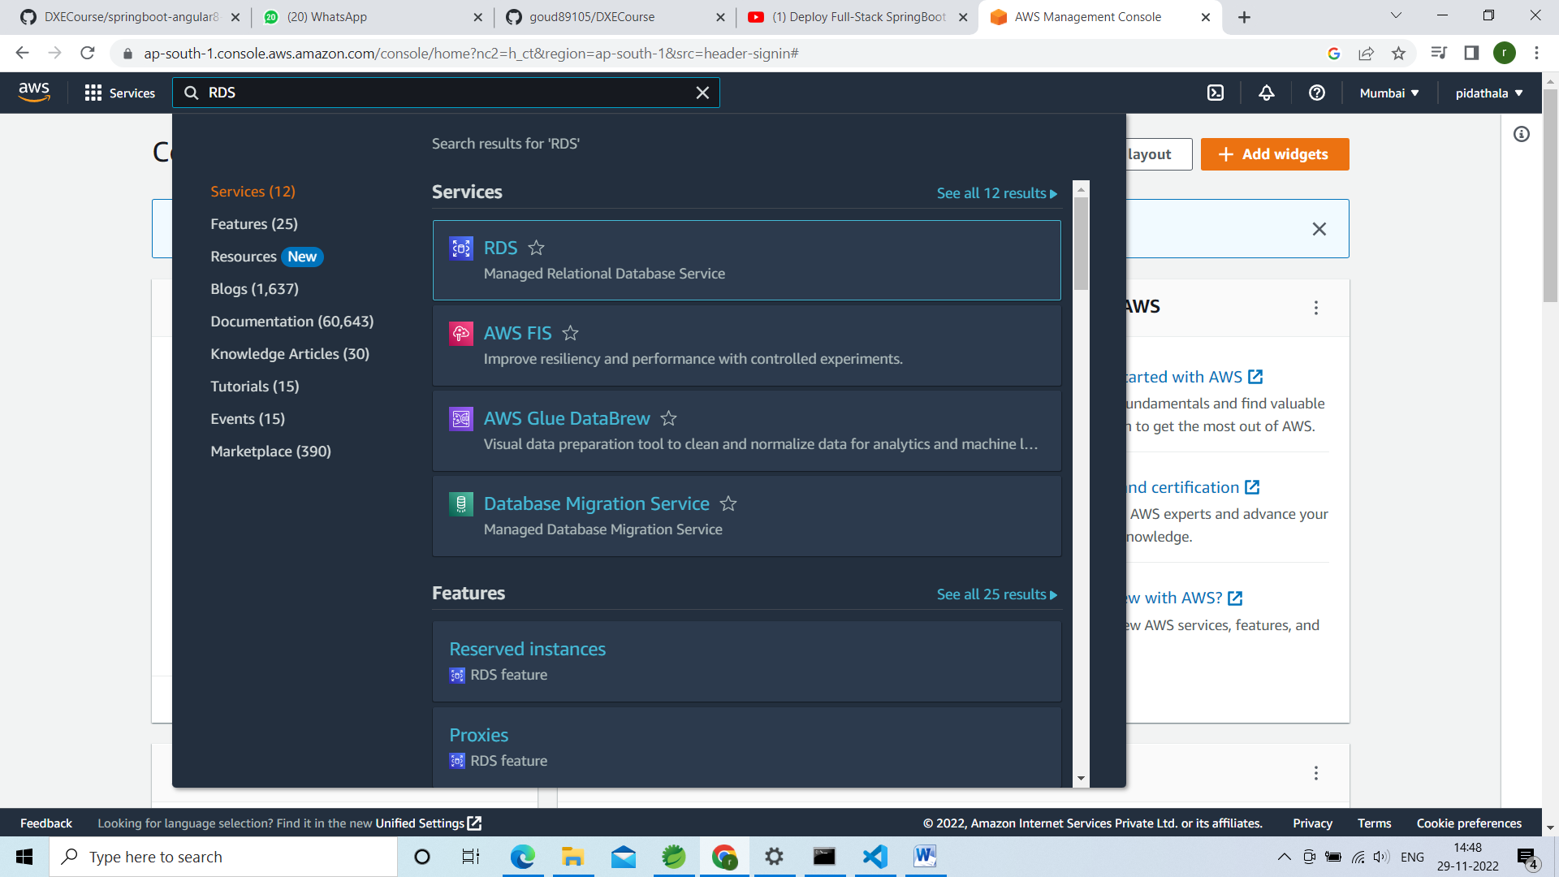

Right click on RDS open in new Tab

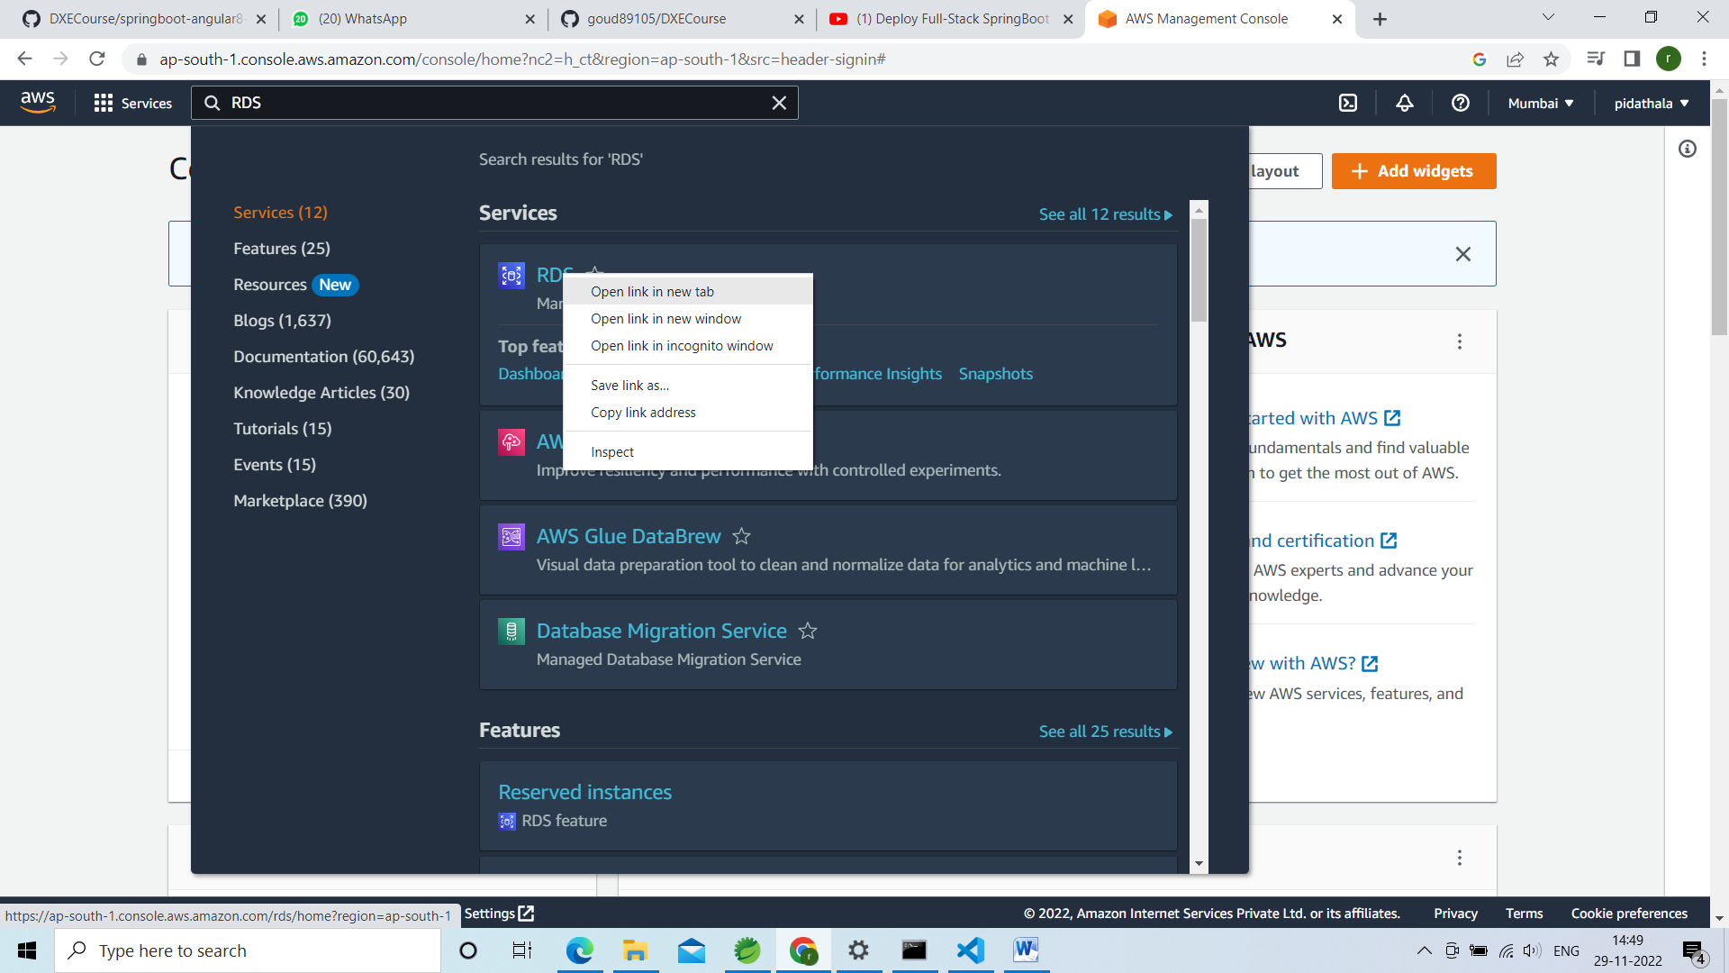

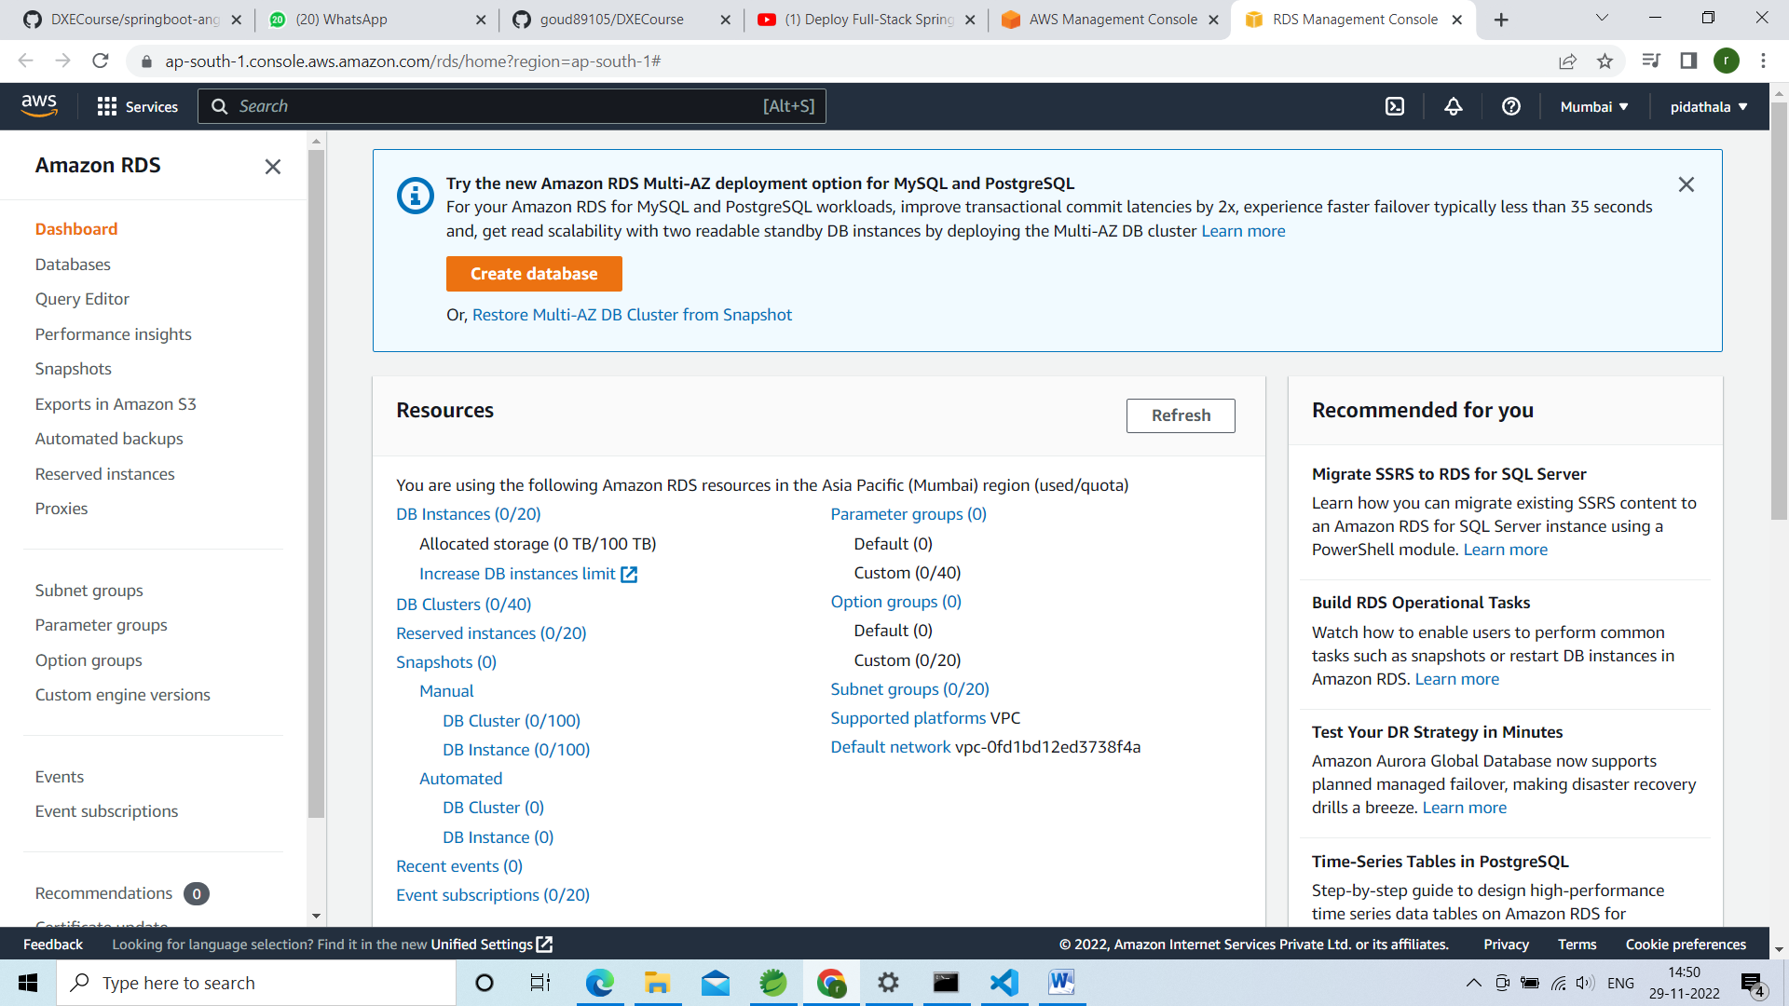

Click on create database lie below

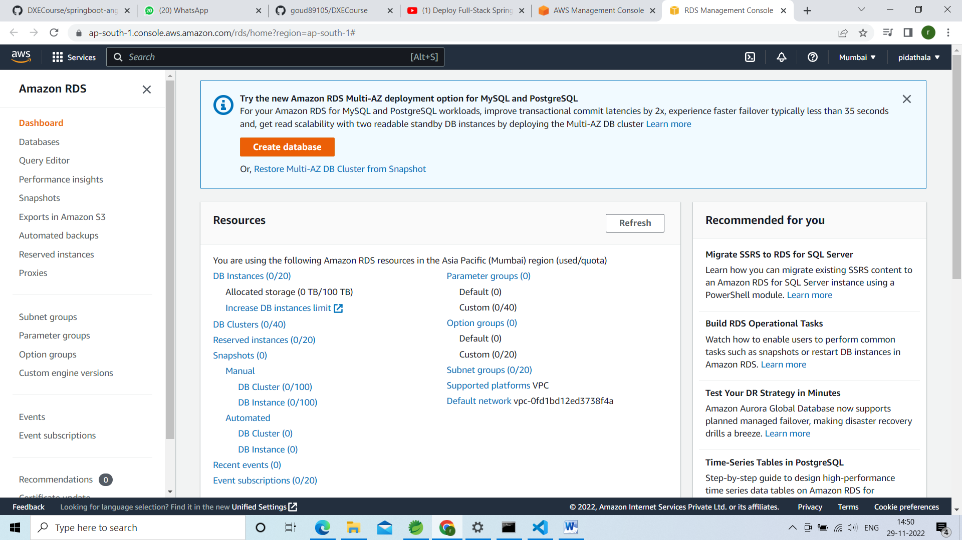

Once click on create database below page will be open

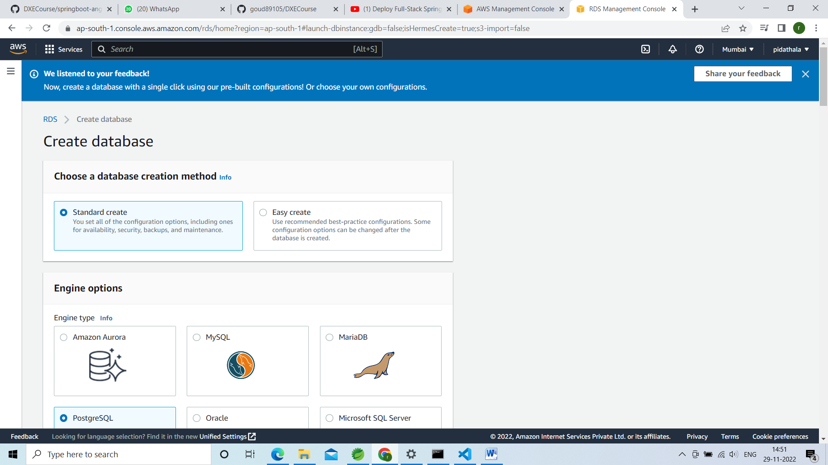

In this page select standard create

Select my sql radio box

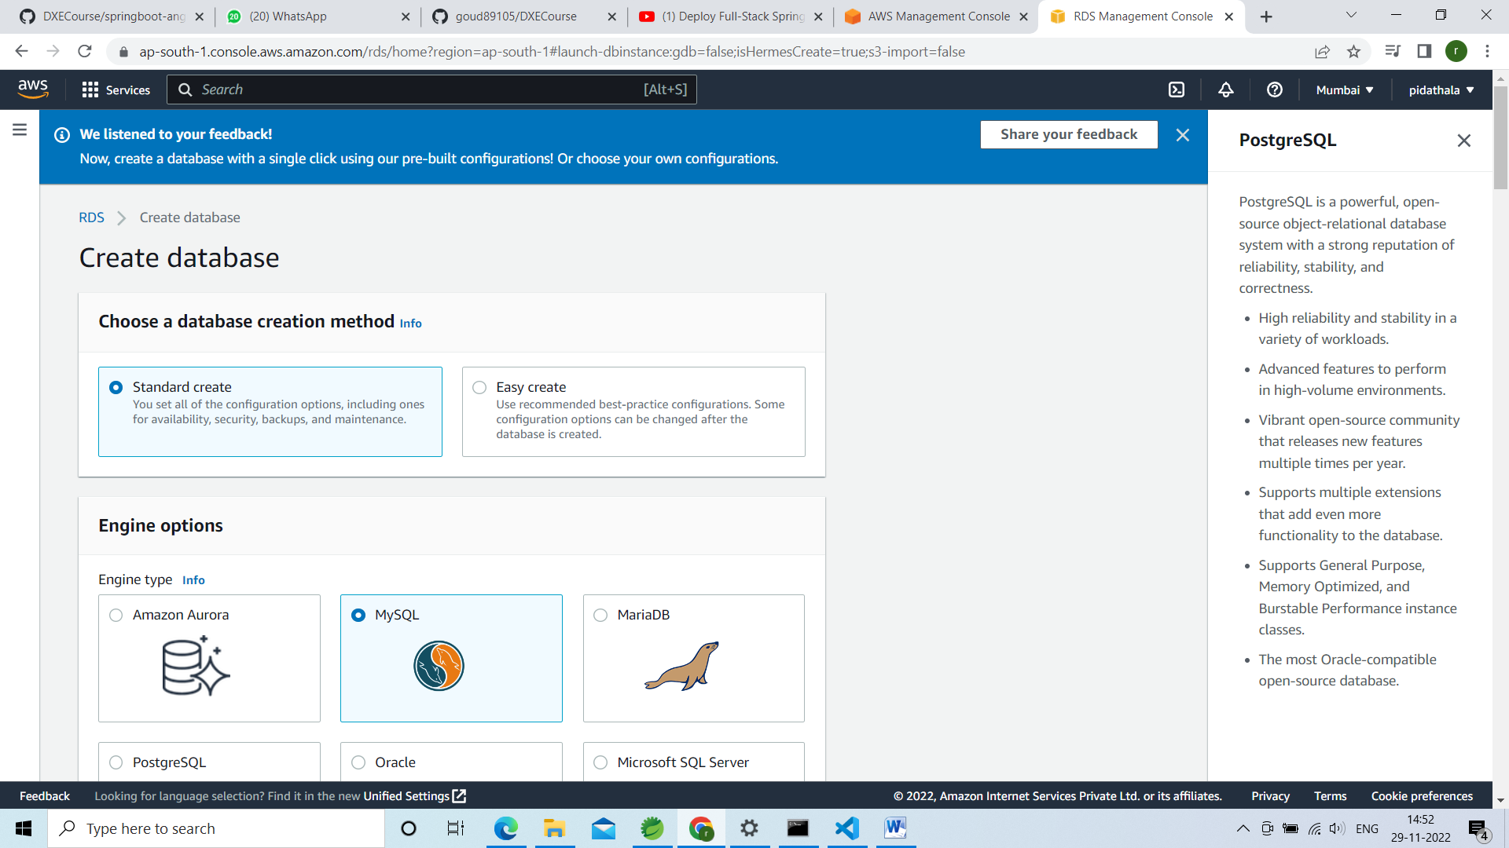

Version and templates like below

Templates freetier

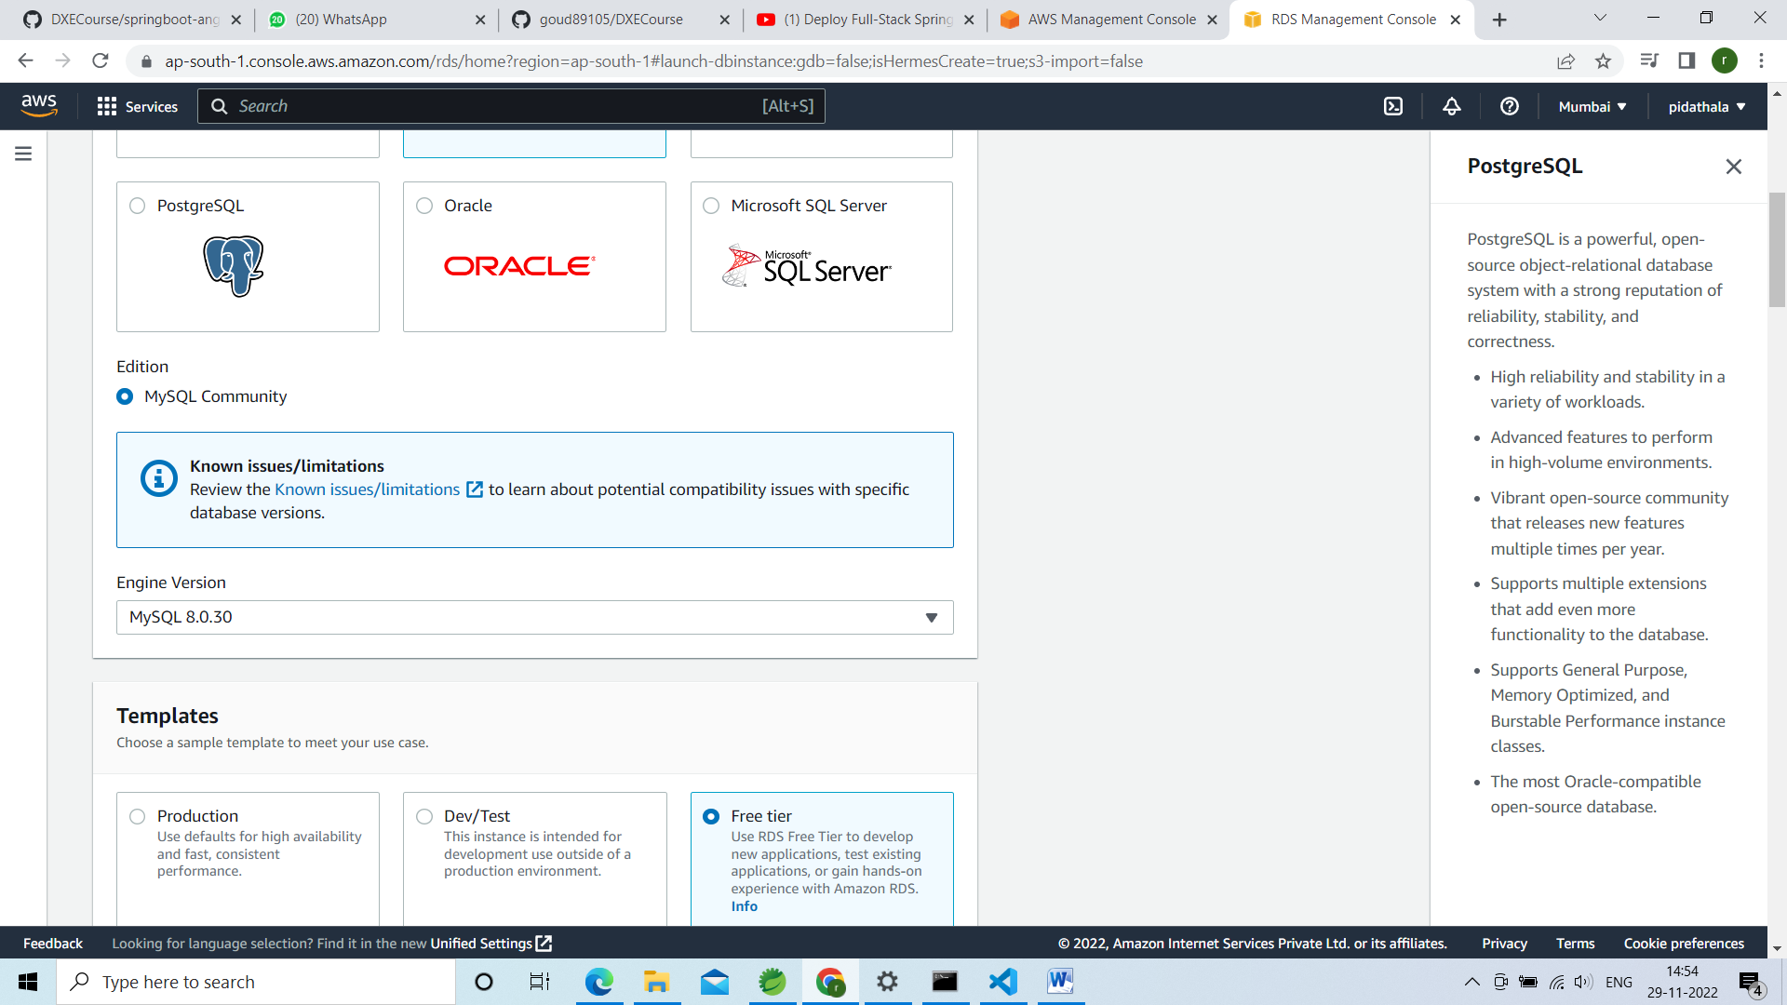

Under settings DB Instance Identifier u can give any name

I have given ustdb

My user name is root

And password u can give ur own password: this password u have to give in application.properties

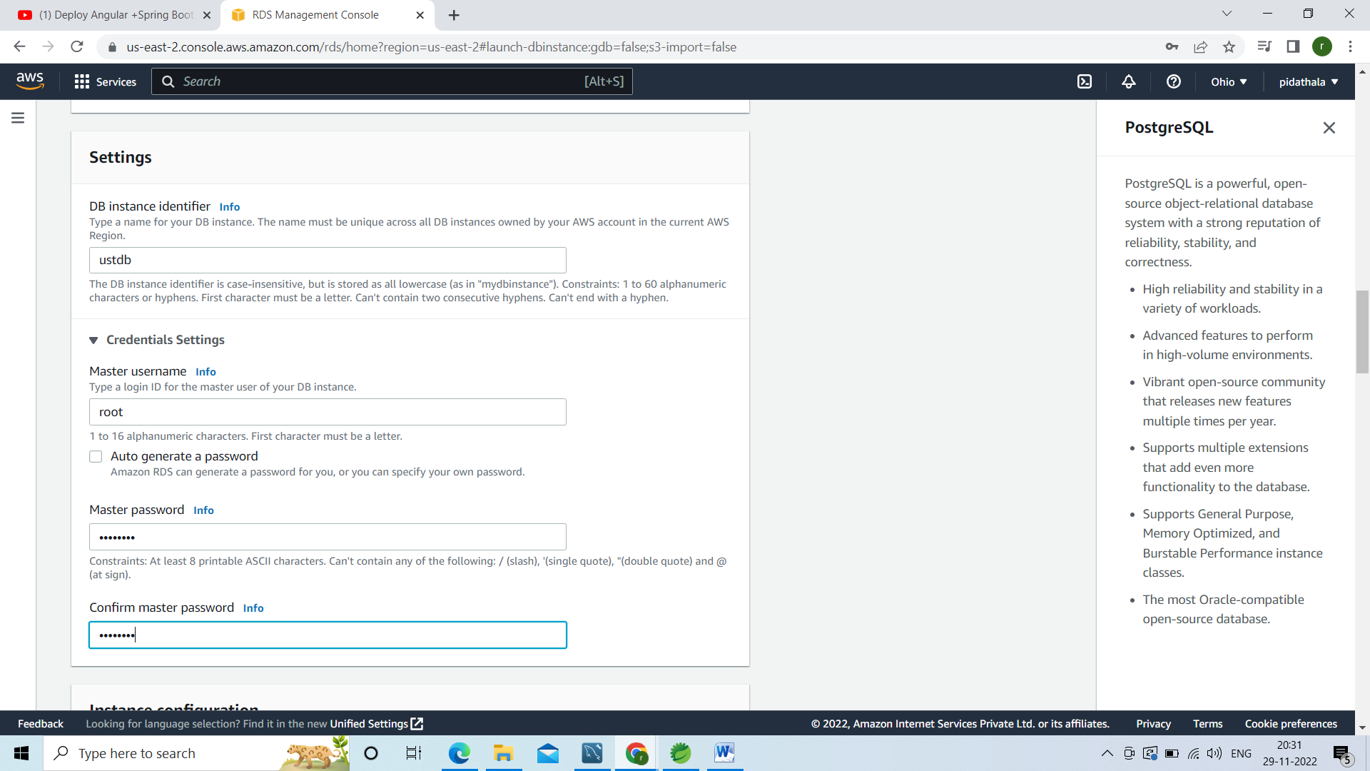

I have given password as Password.

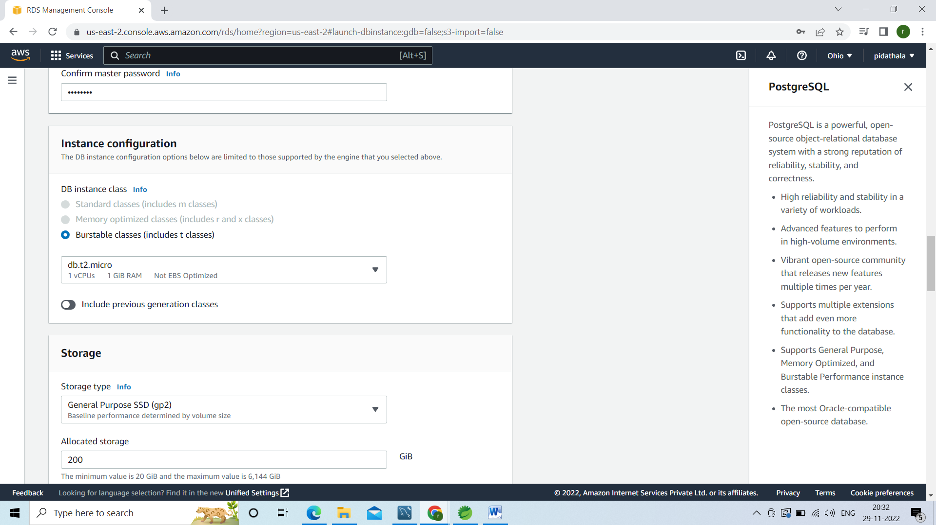

In public access u have to select Public

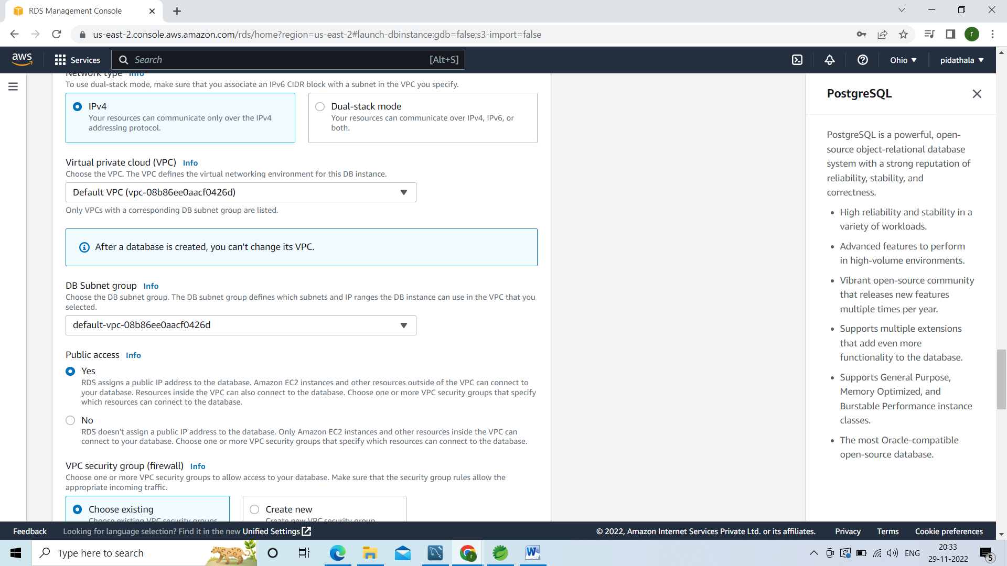

In additional configuration u have to give ur schema

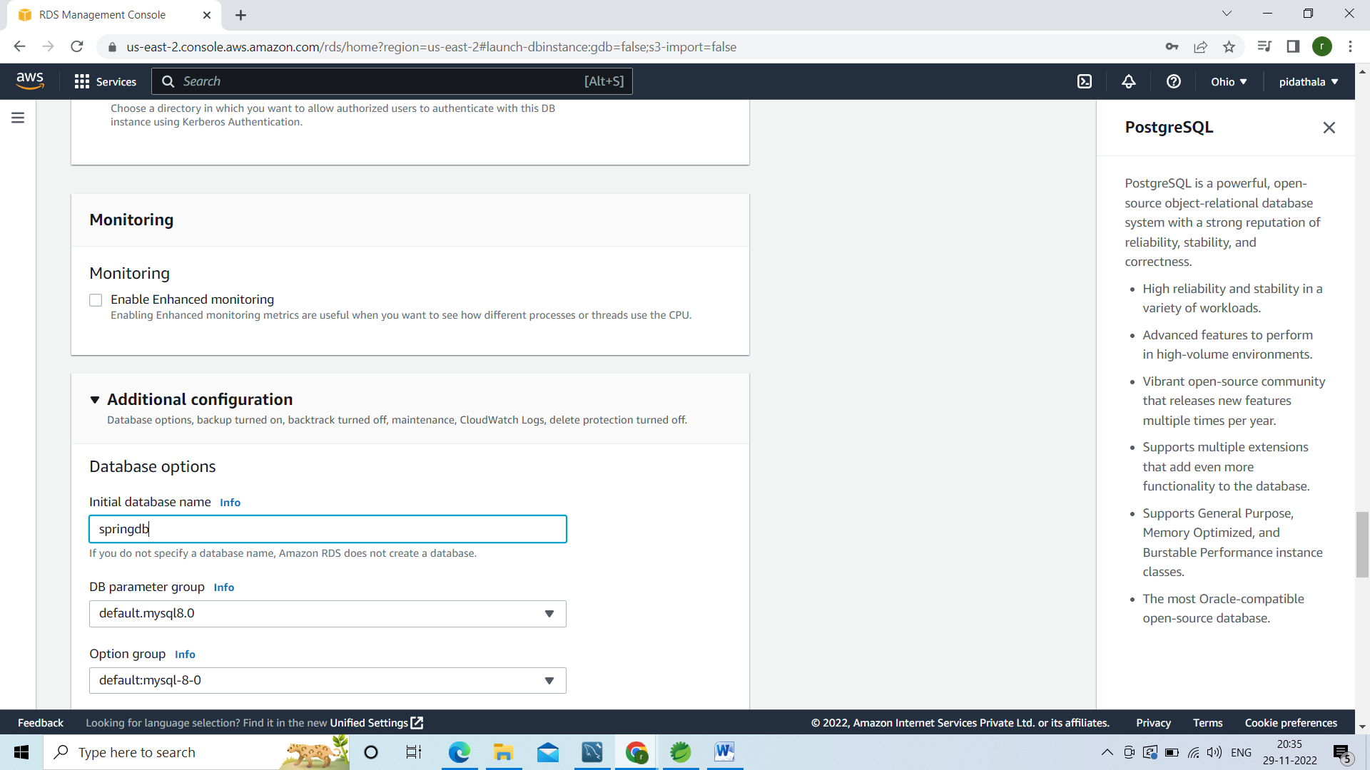

Now click on create database

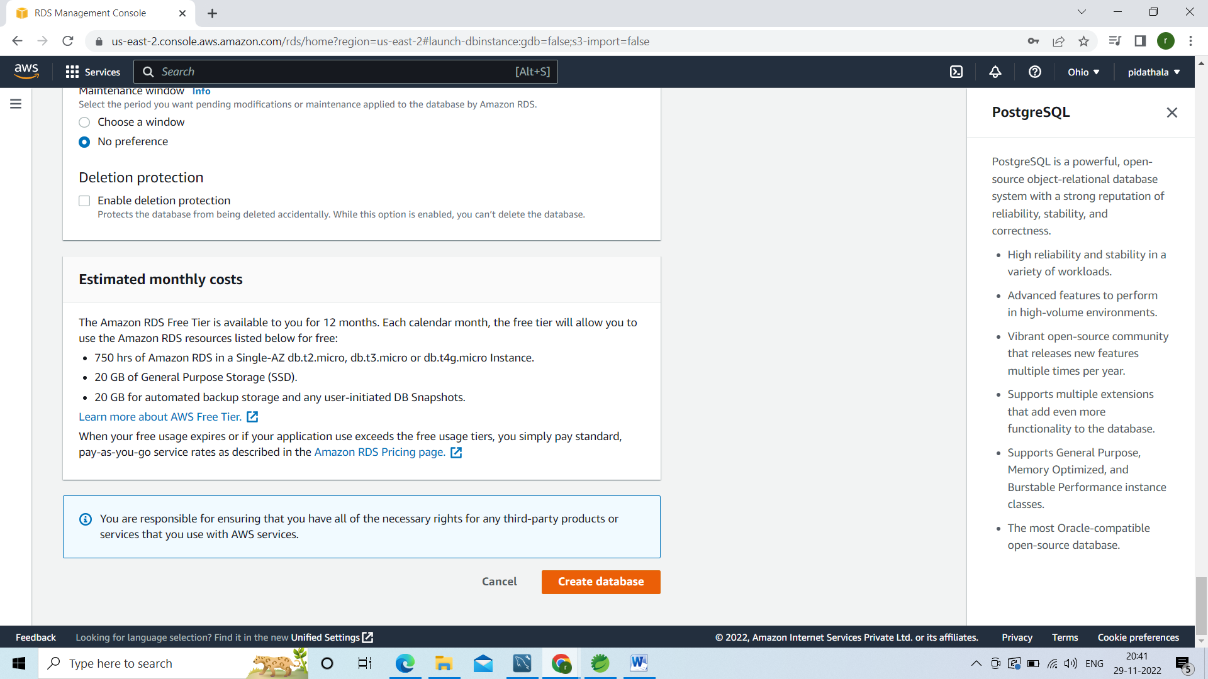

Here it will take some time to create the database

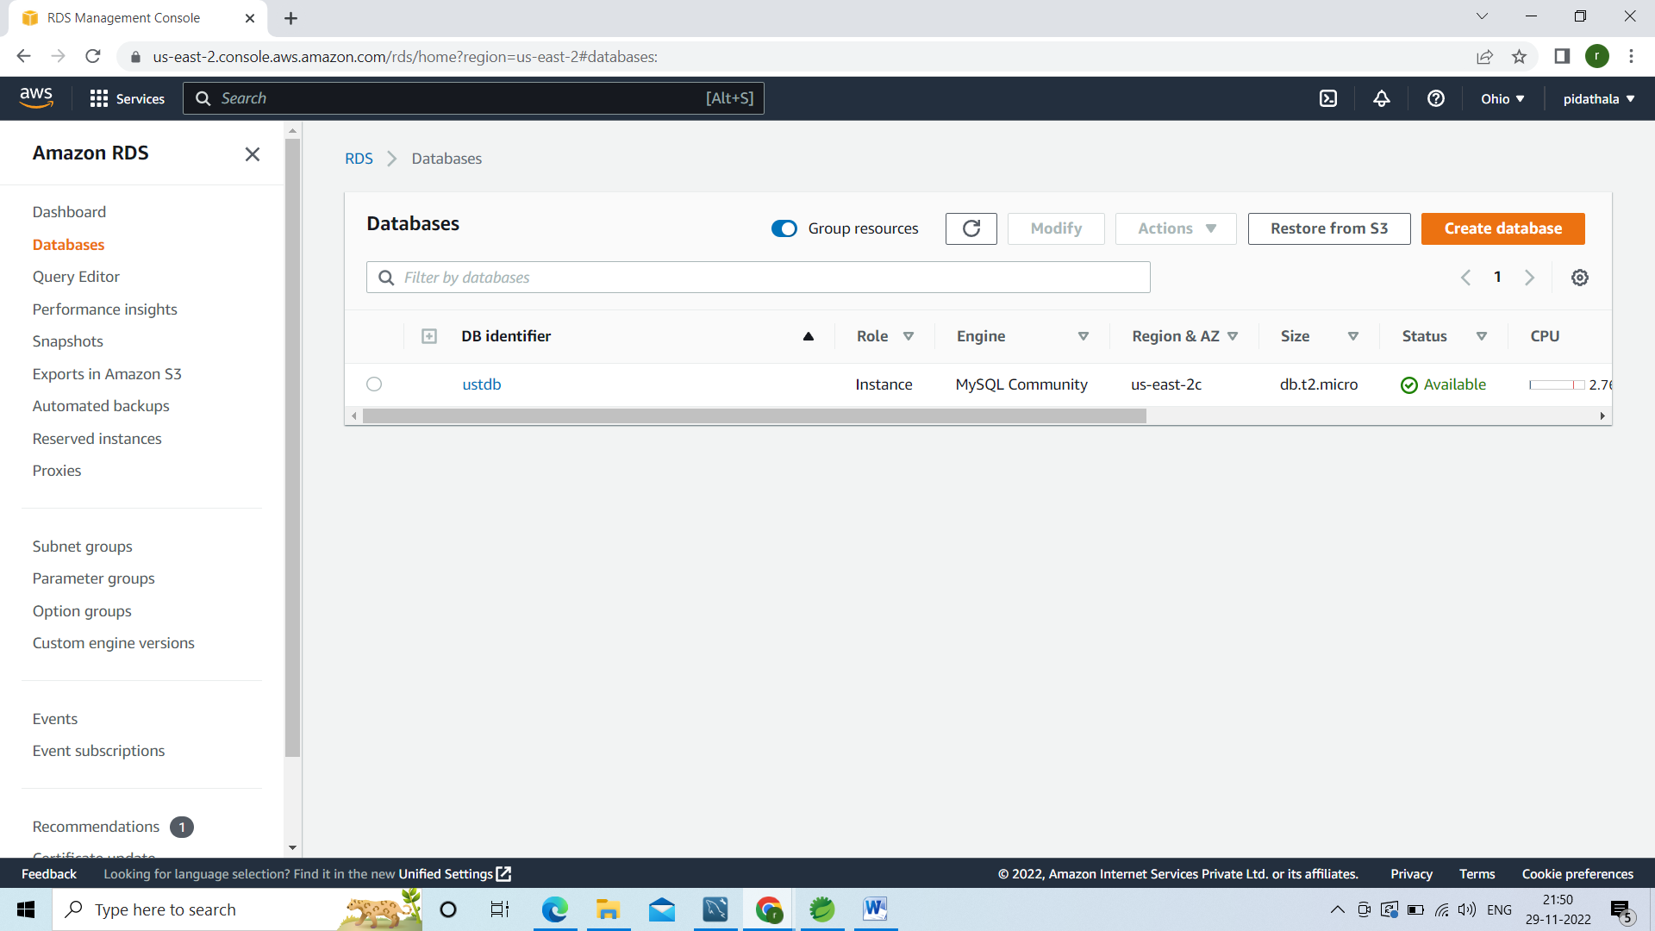

Now right click on ur db name and open in the new tab

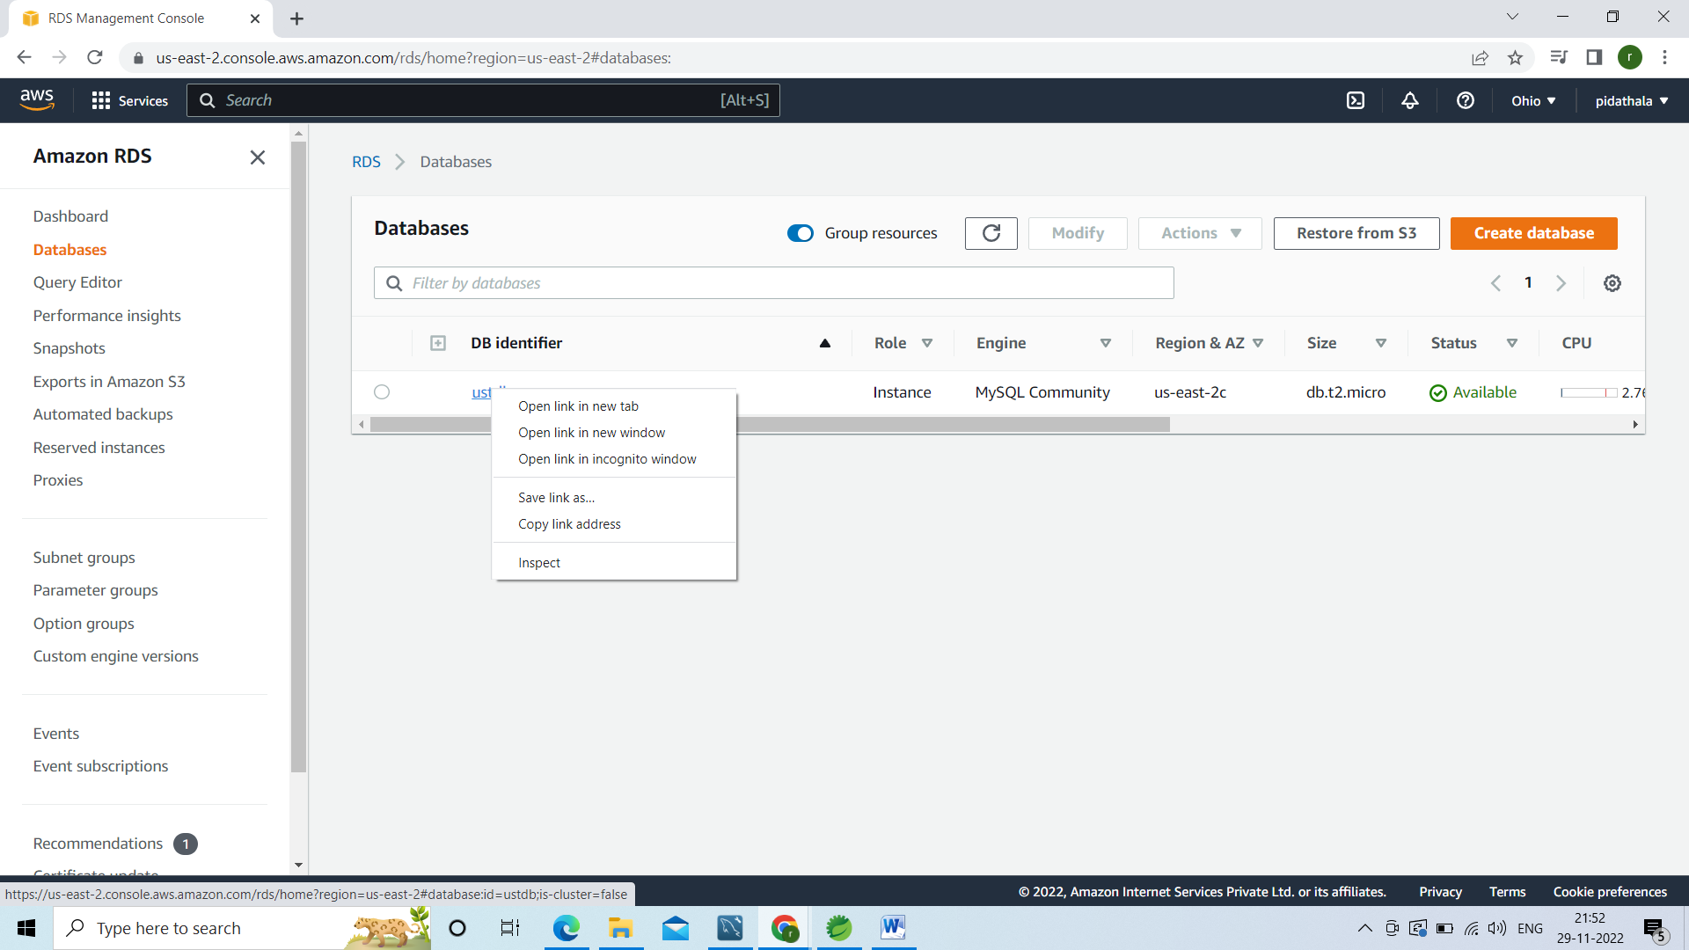

Copy the end point in the below page

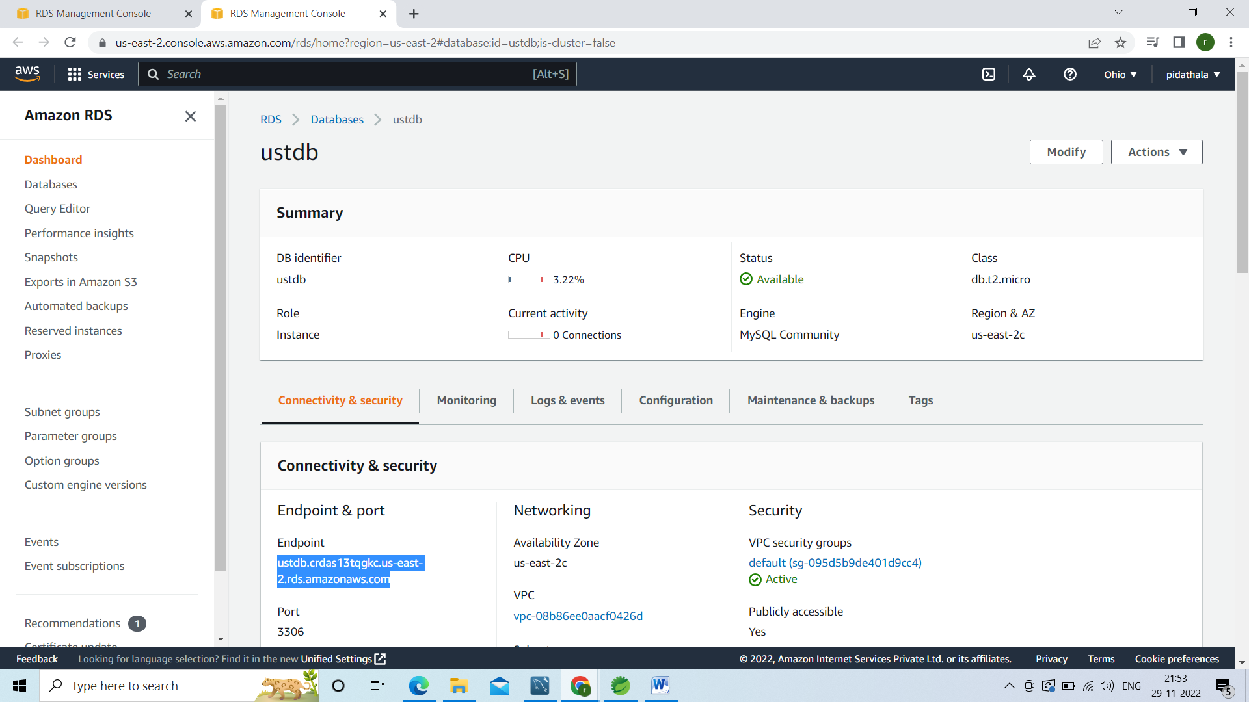

Go to ur application.properties file instaed of loaclhost give this endpoint

And user name should be:root

Password should be whatever u have given in the page no:5

Since we are using elastic bean stack server port should be 5000

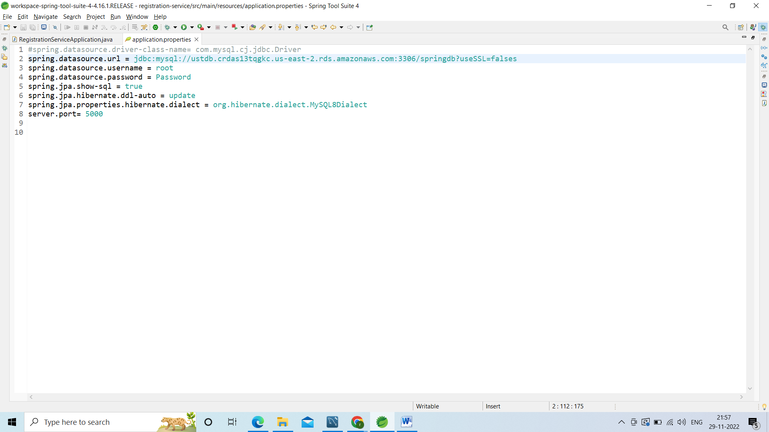

Go to security click on default

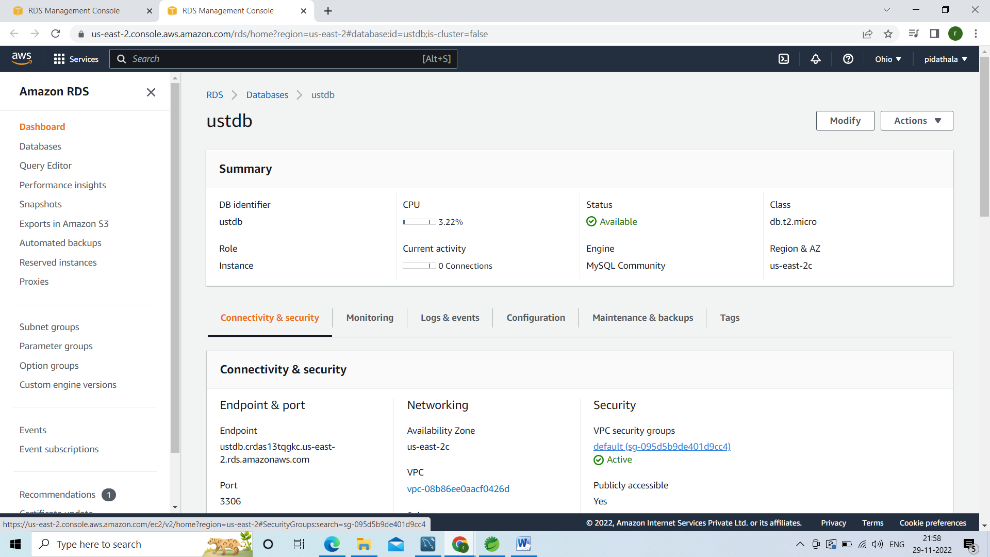

Again click on security group id

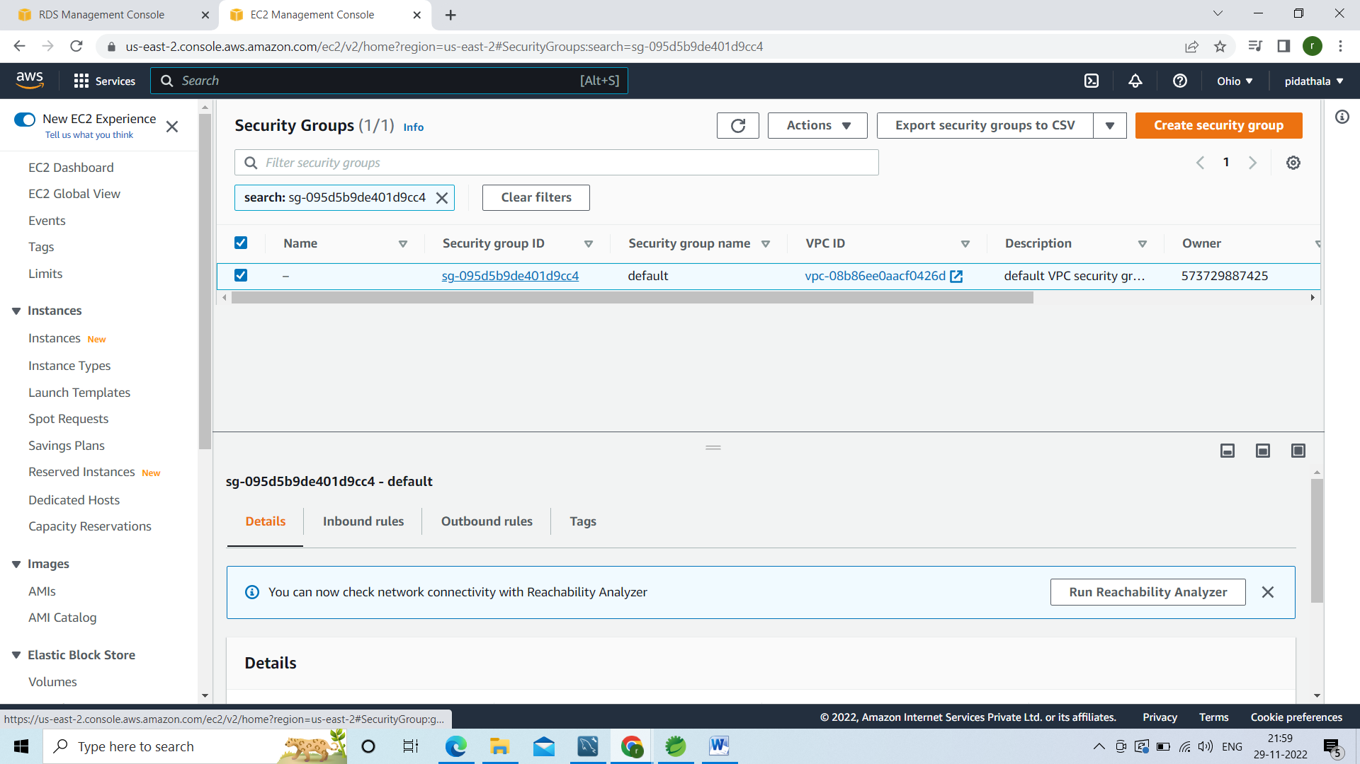

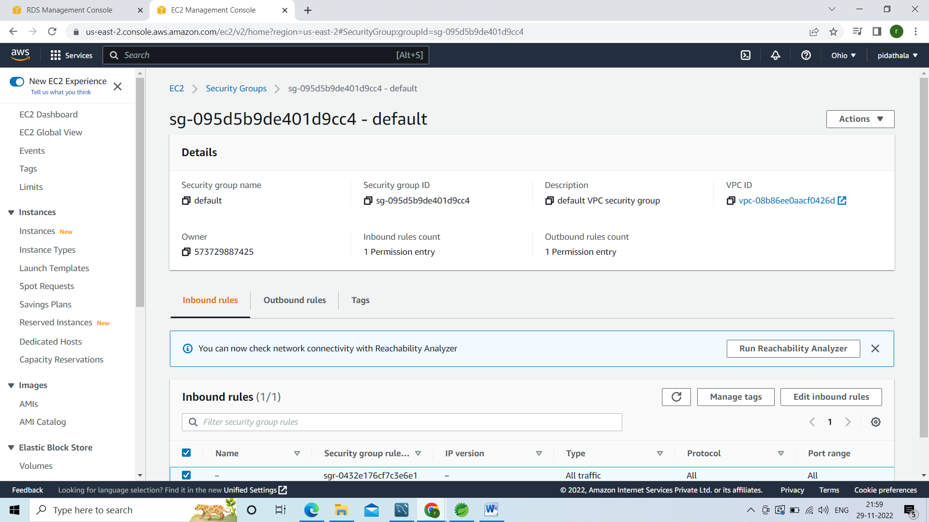

Click on edit bound rules in the below page

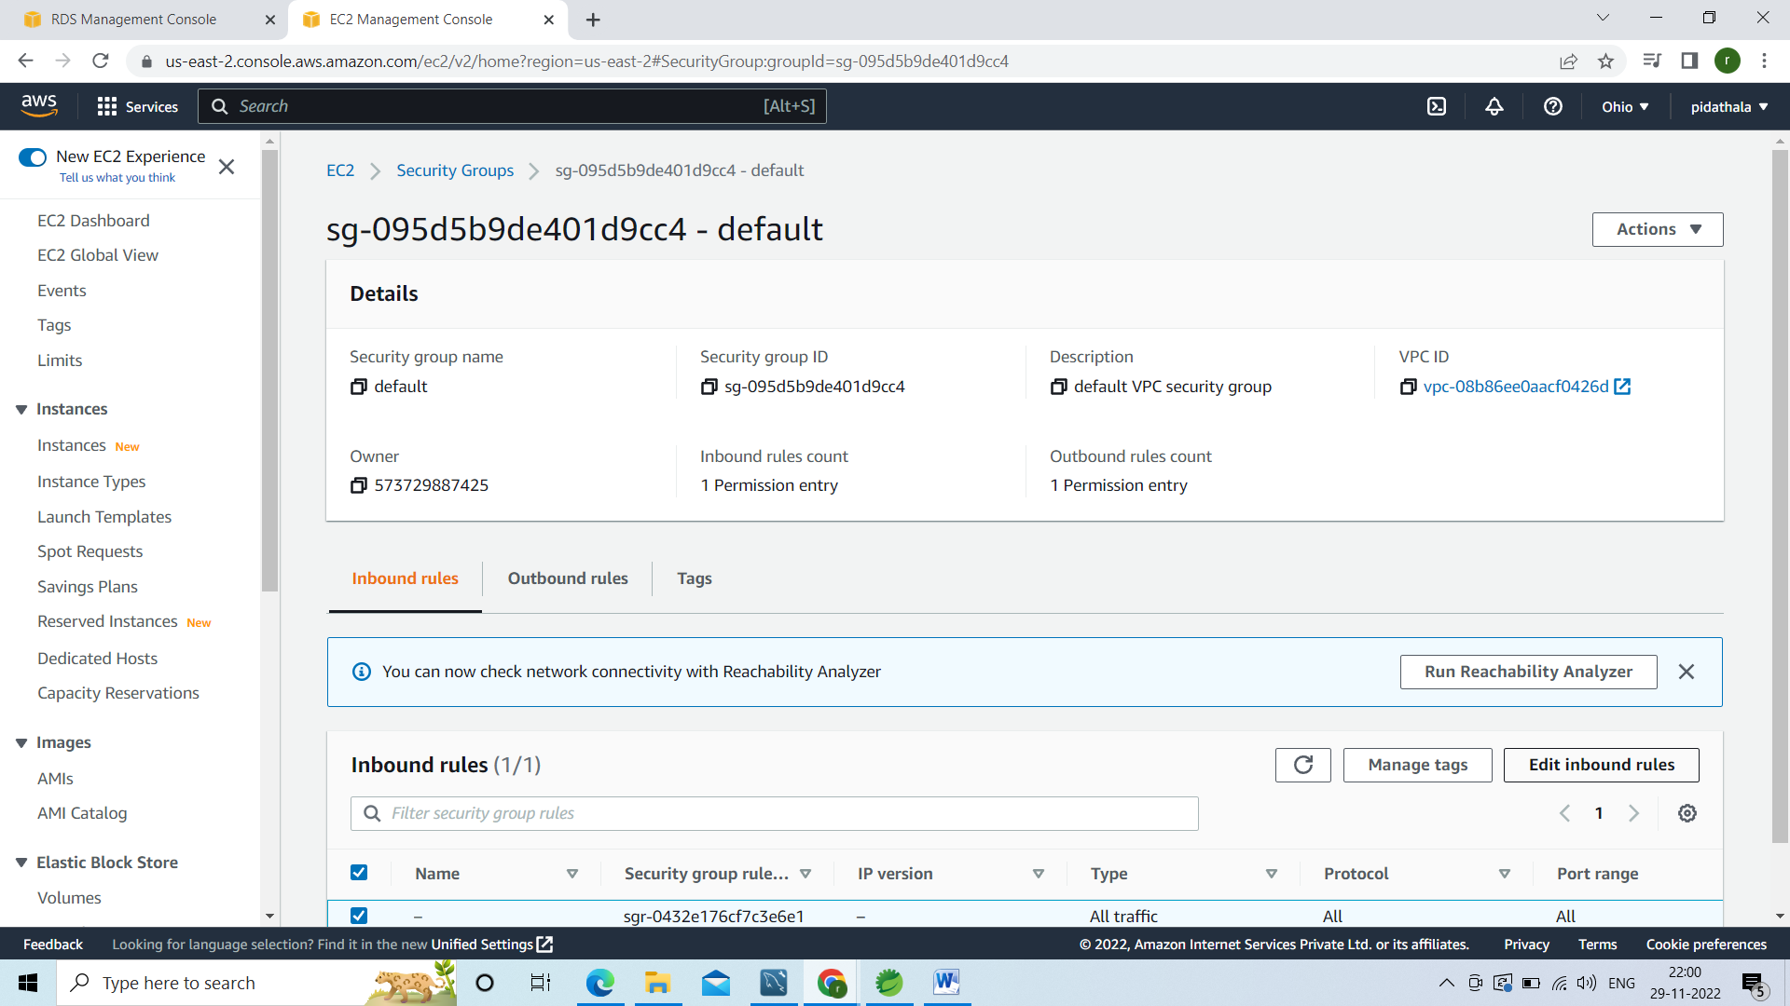

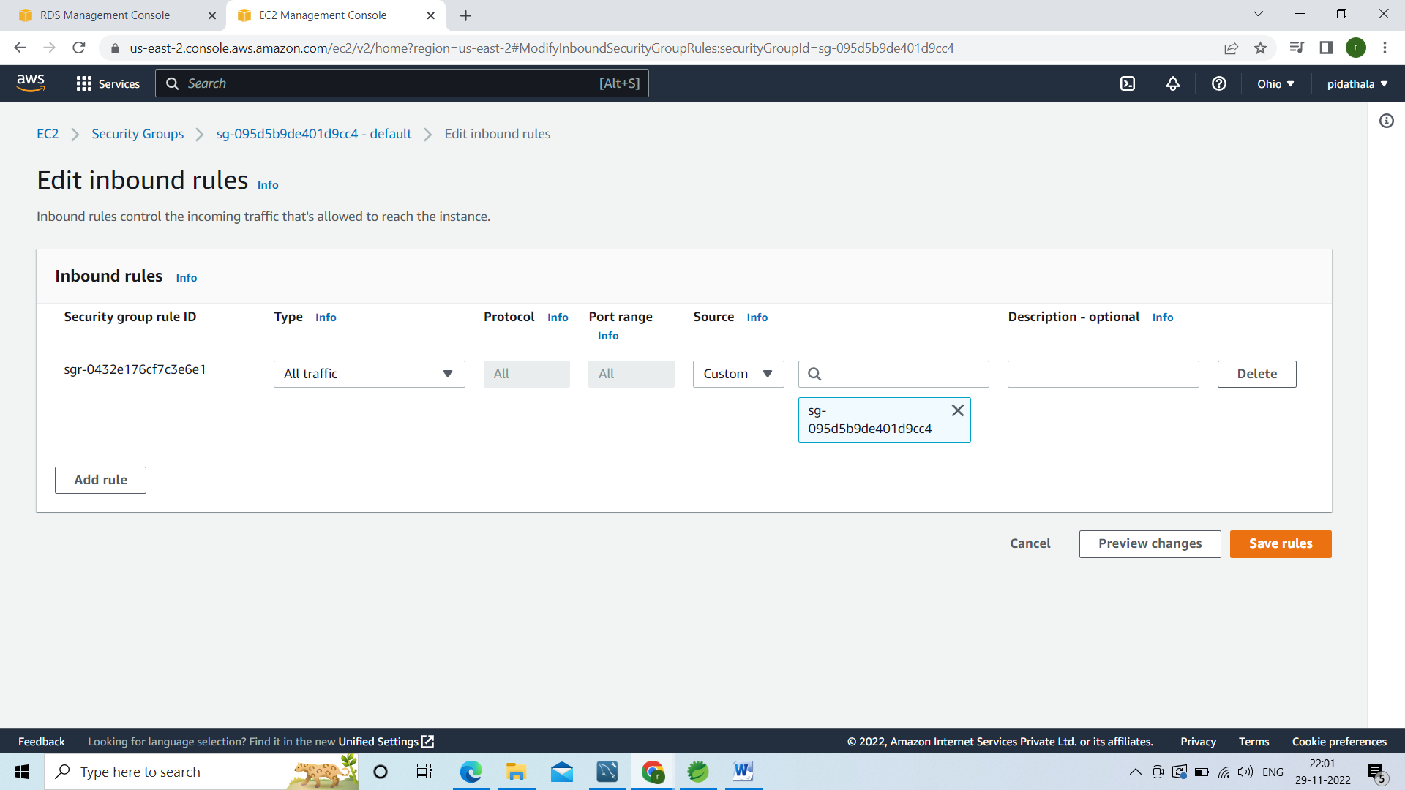

Click on add rules

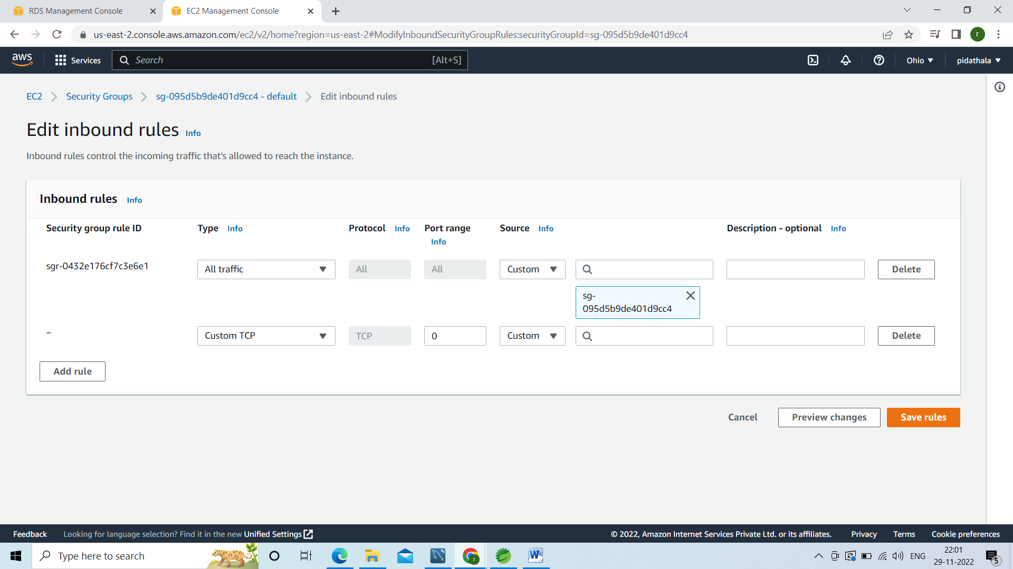

Instead of custom TCP Choose mysql and instead of custom anywhere then save rules

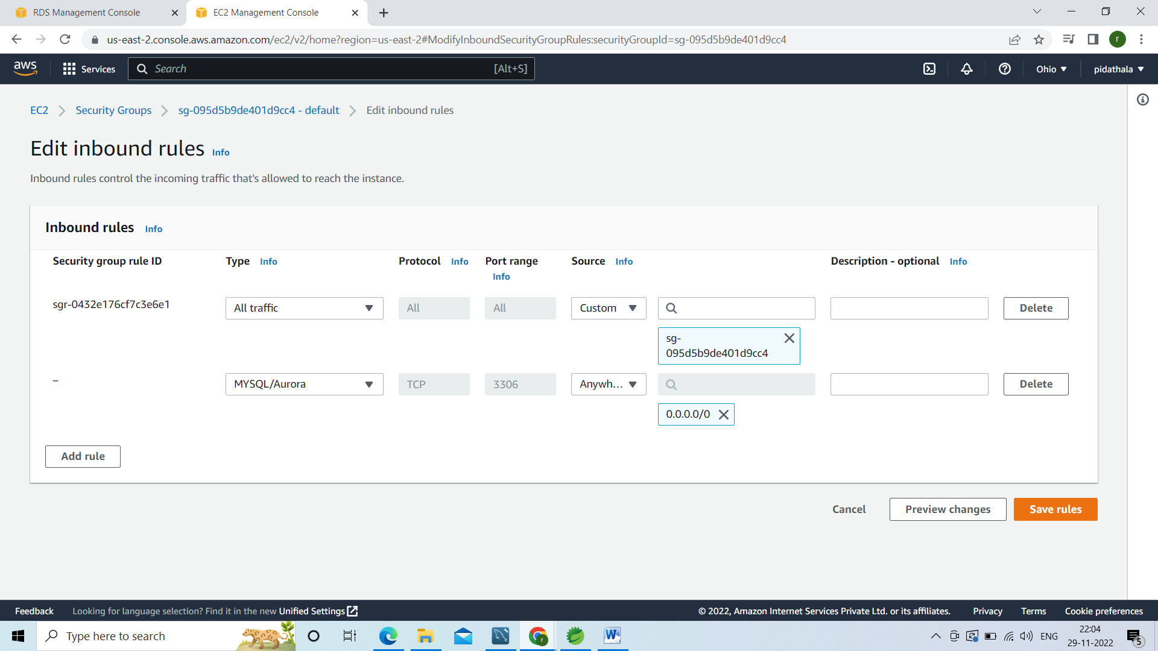

Click on save rules

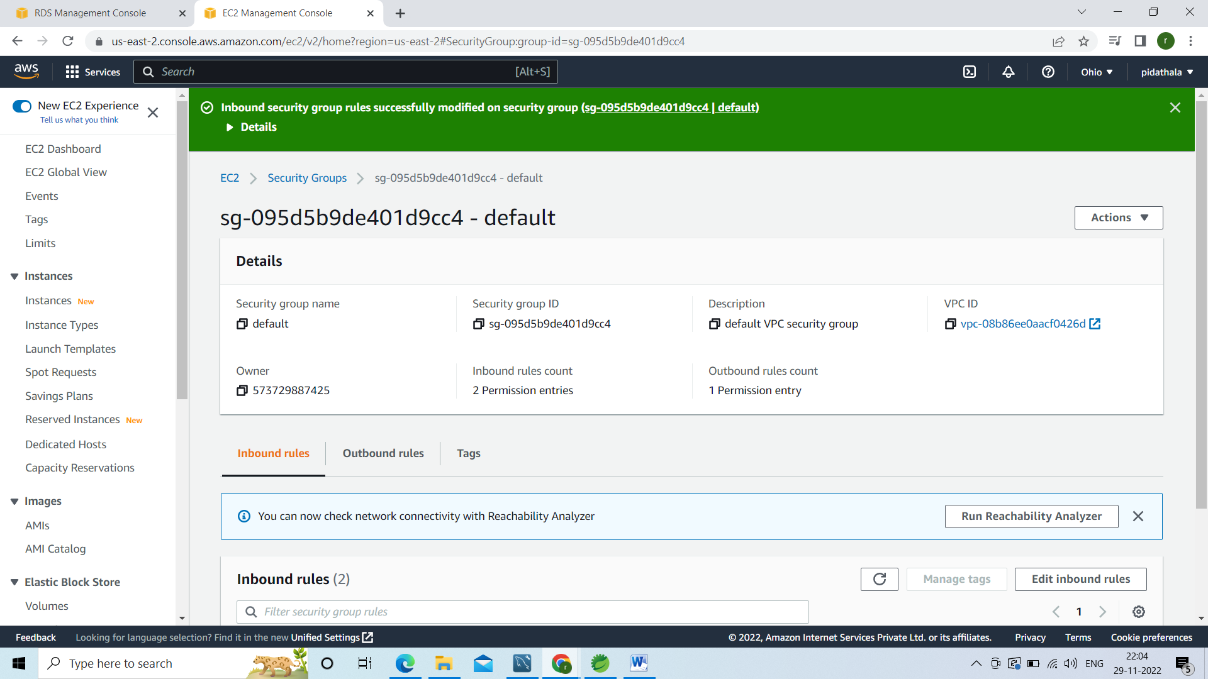

Then go to our spring boot application create the jar.

For that right click on project run as maven build

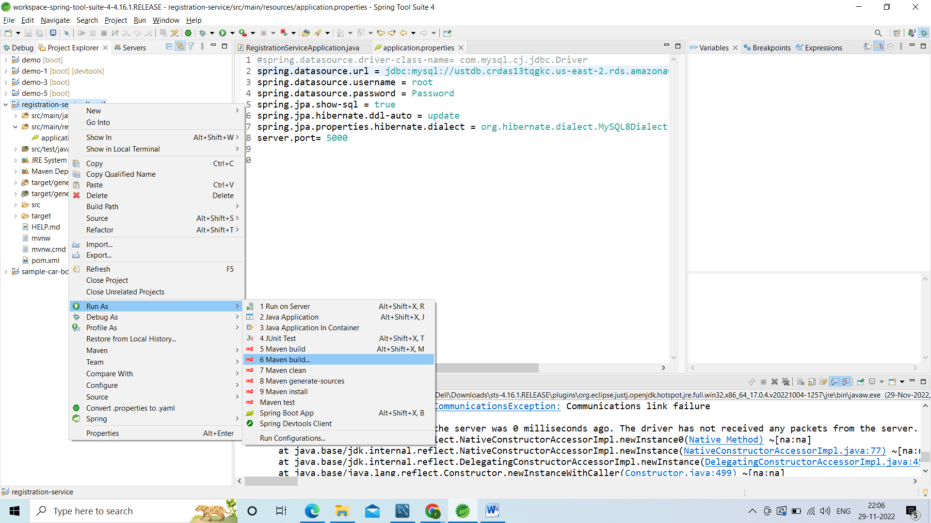

In the

goals u have to give clean install and apply and run

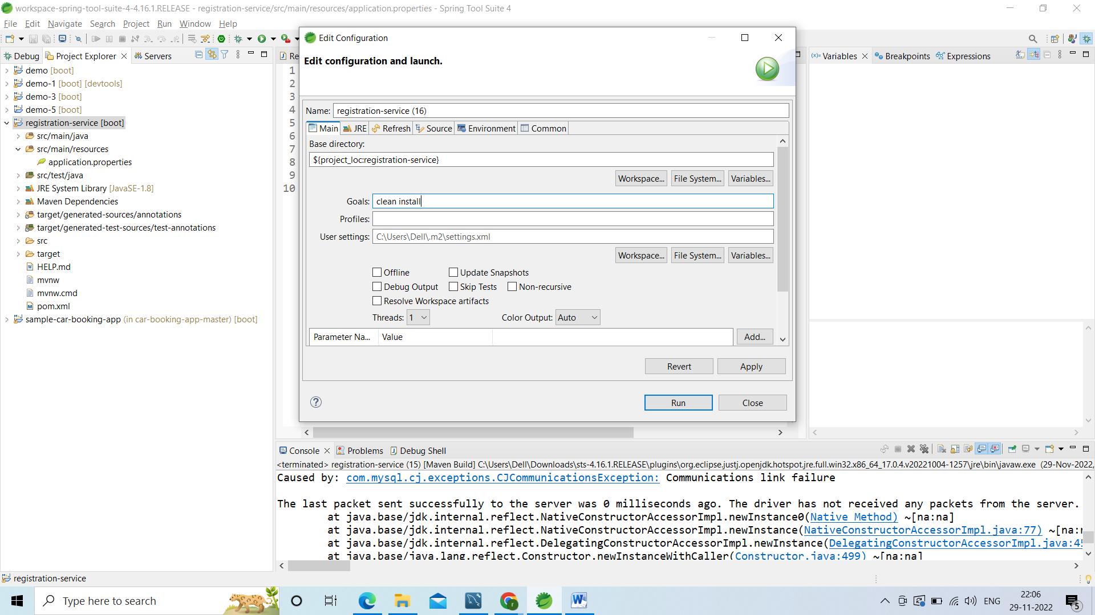

Build got success

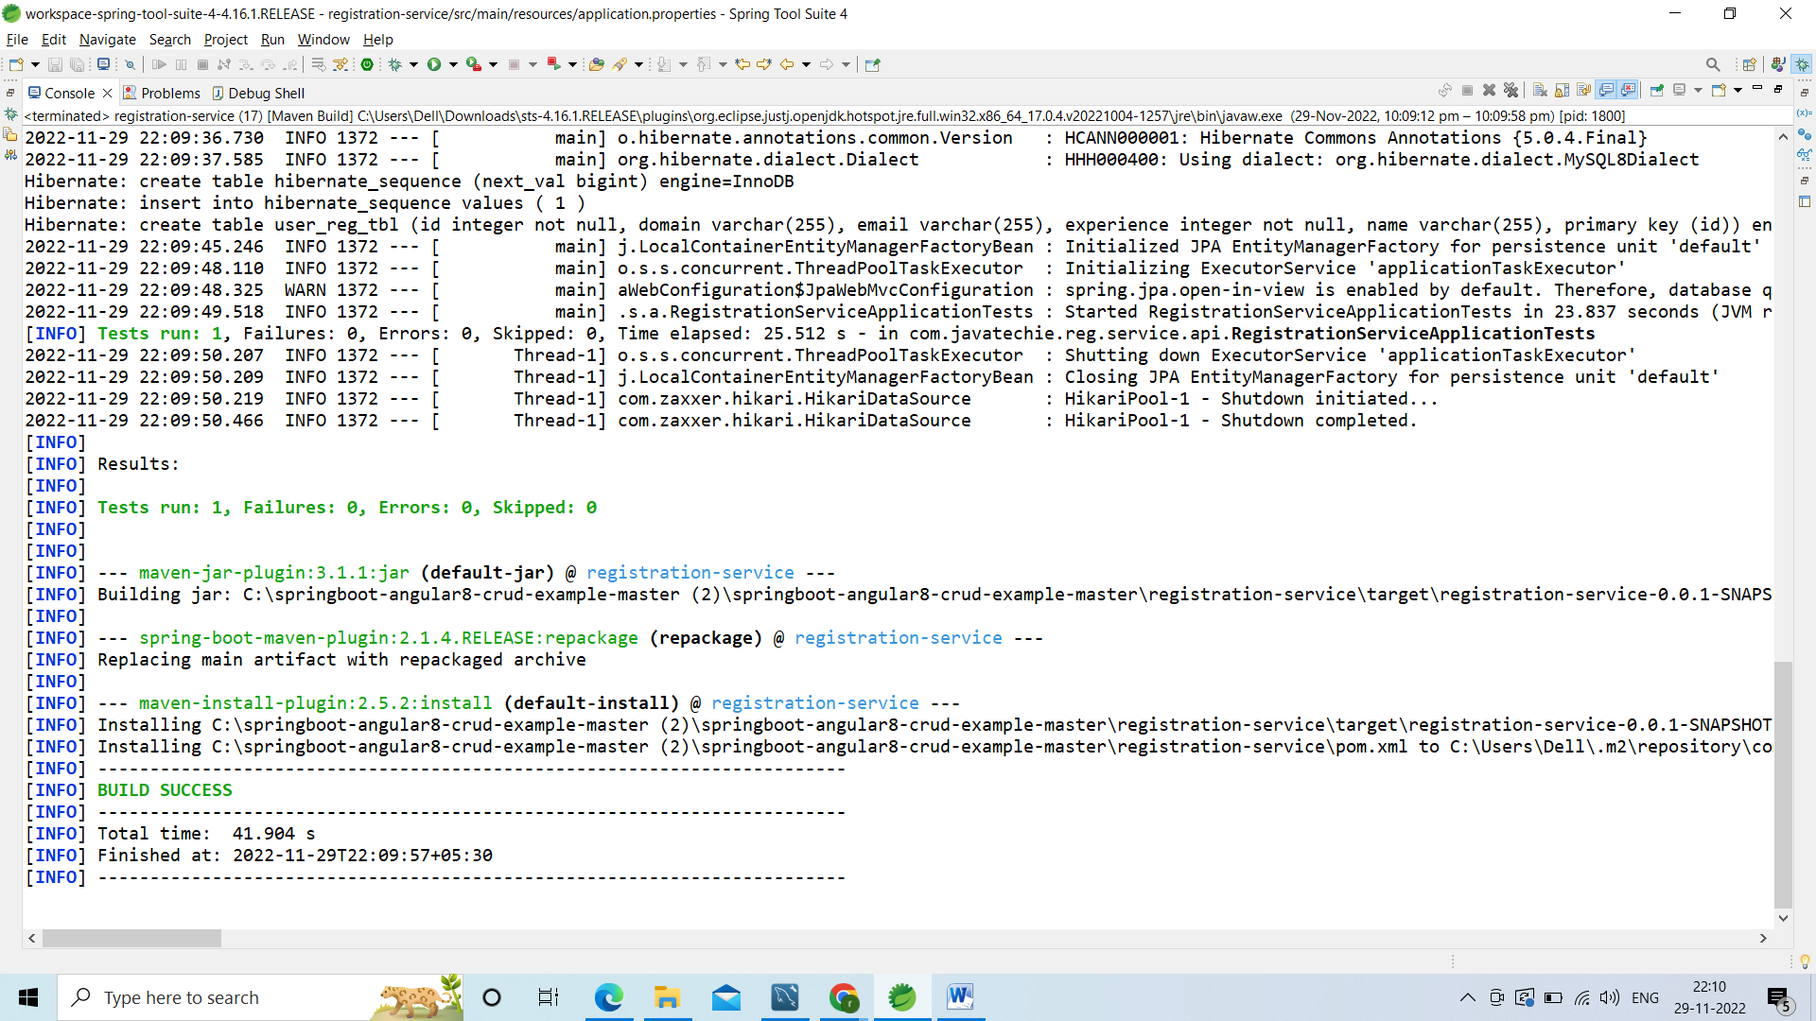

Go to ur project right click on target folder and refresh u r jar will be available inside this folder.

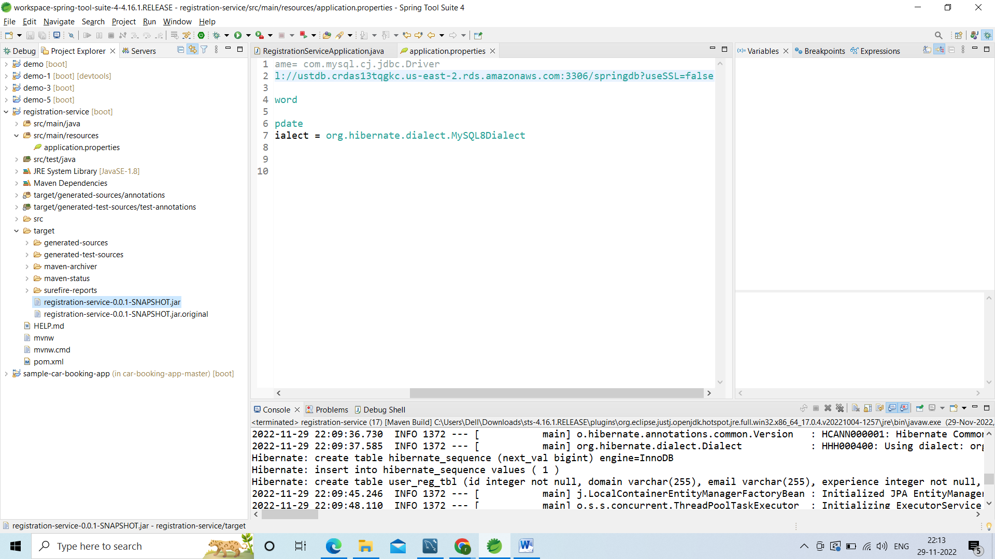

Go to ur aws console search for elastic beanstalk

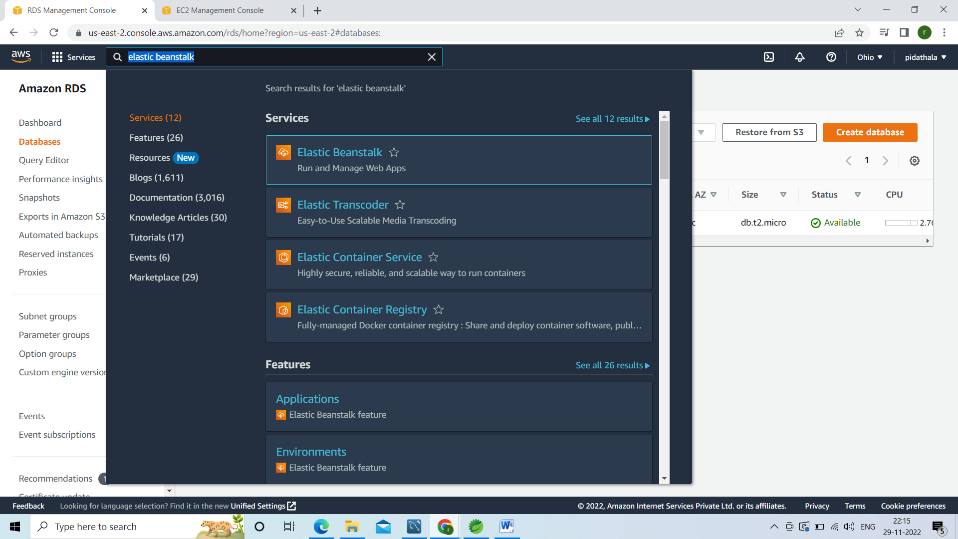

Right click on elastic beanstalk open in new tab

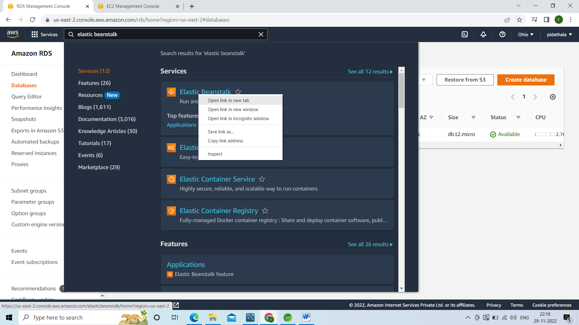

Going to deploy ur jar file in elasticbean stalk

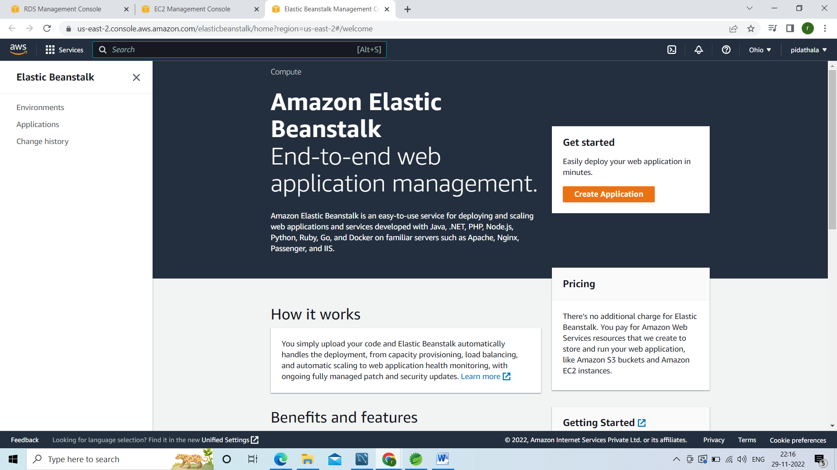

Internally it will create the s3 bucket store it in ec2 instance

Click on create application

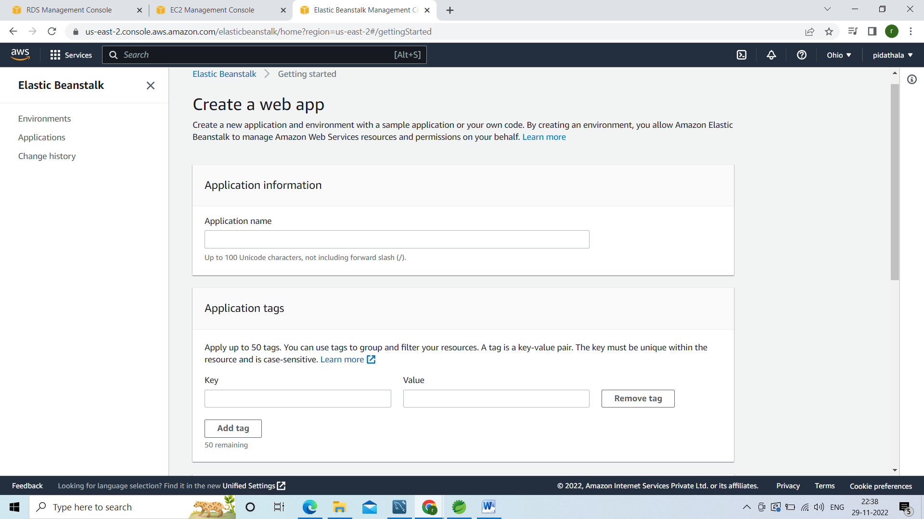

Give application name can be any name am giving user-service

Application tags leave as it is

In plat form select java in platform branch select java8

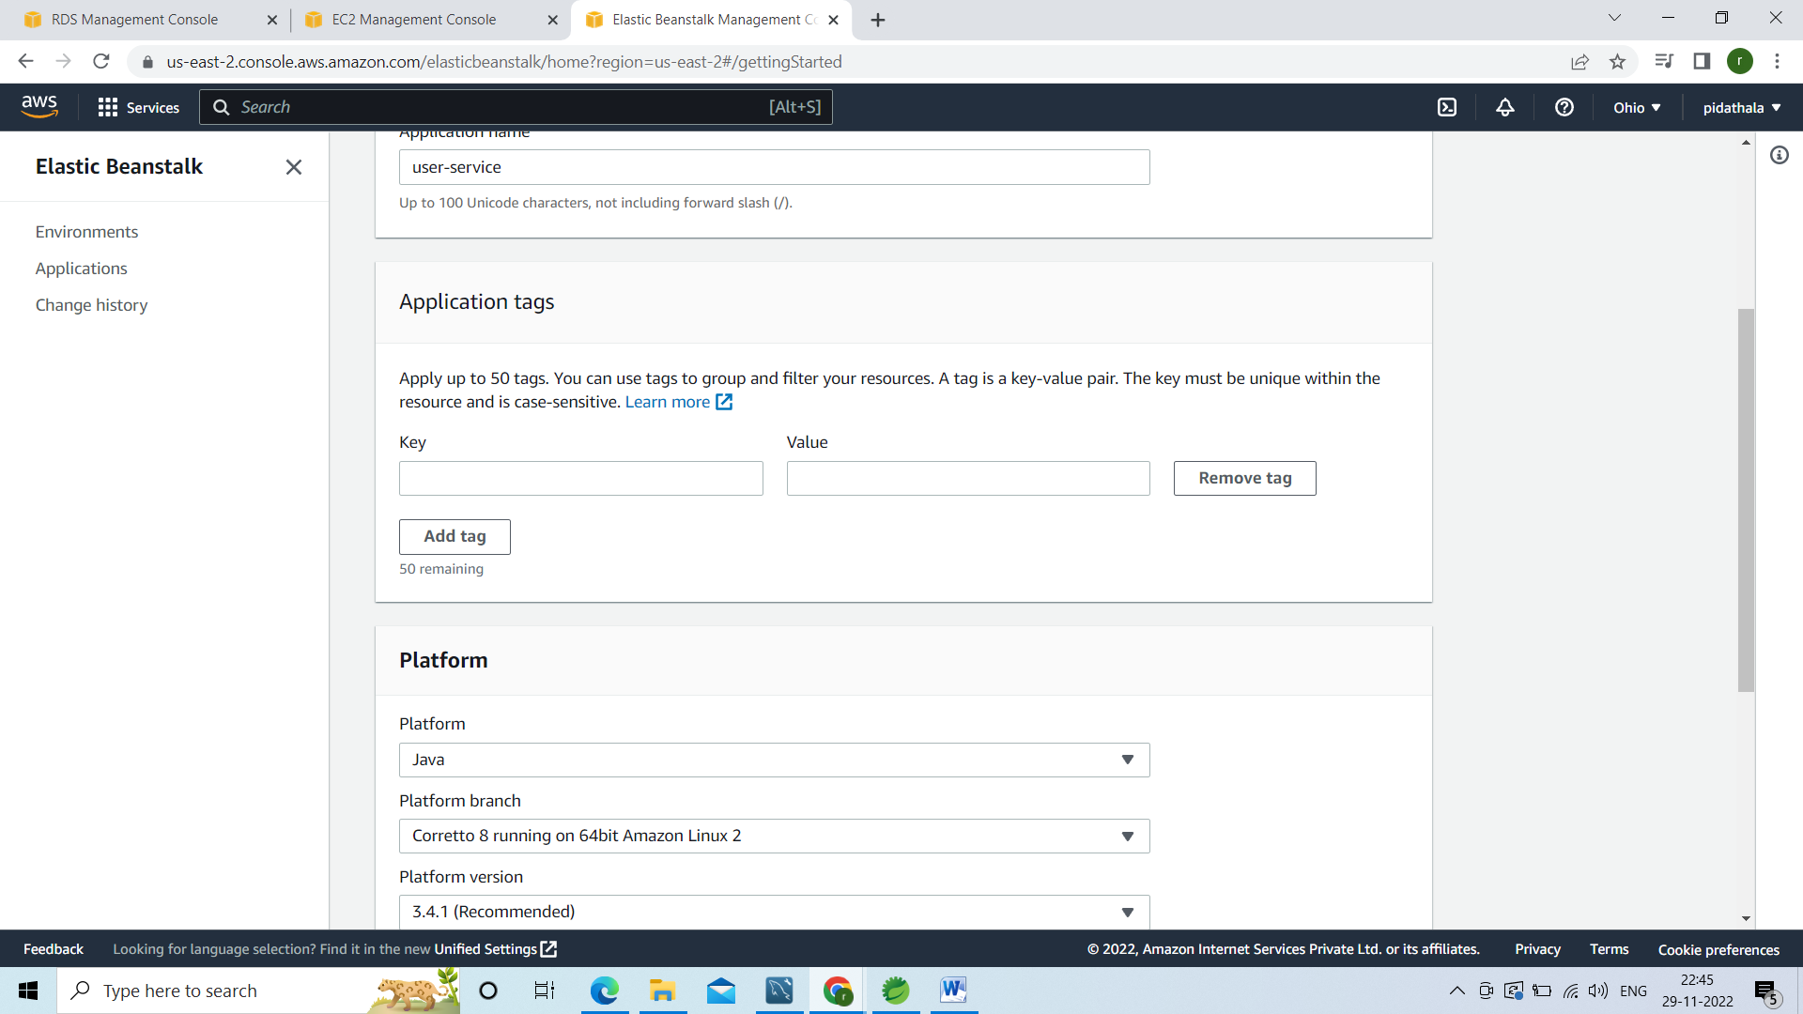

Now click on configure more options bcz u need to configure mysql user name and paasword

Go to ur database section click on edit

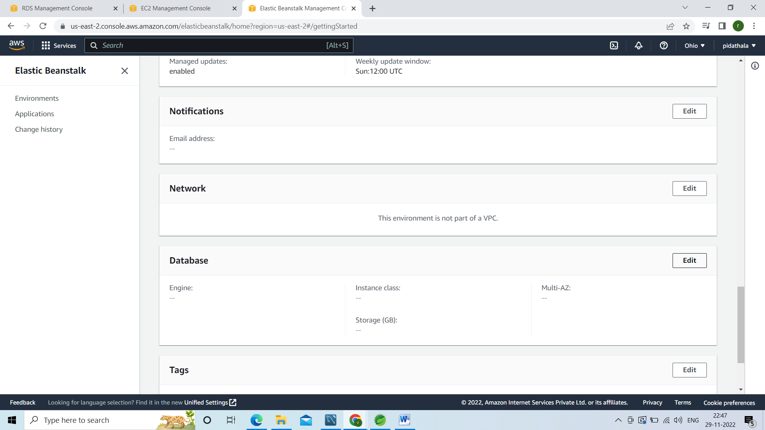

U need to give the username and password of ur rds instance checu ur application.properties firl for usernamd password

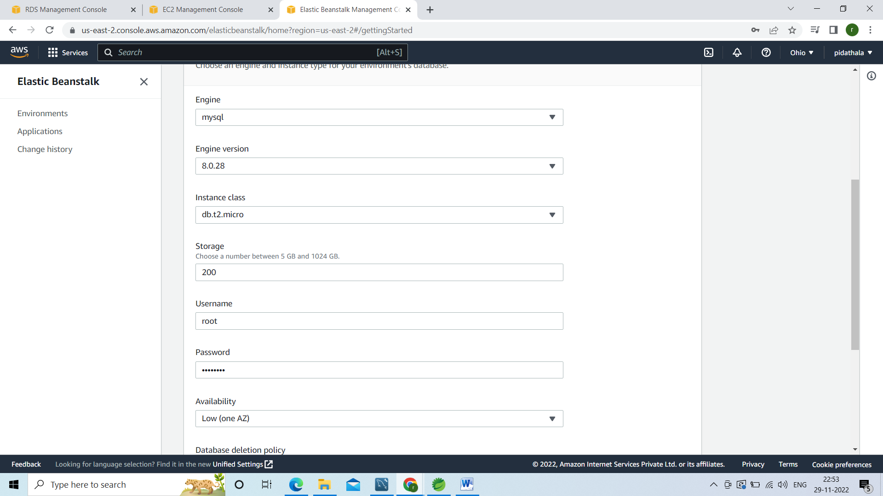

Now click on save

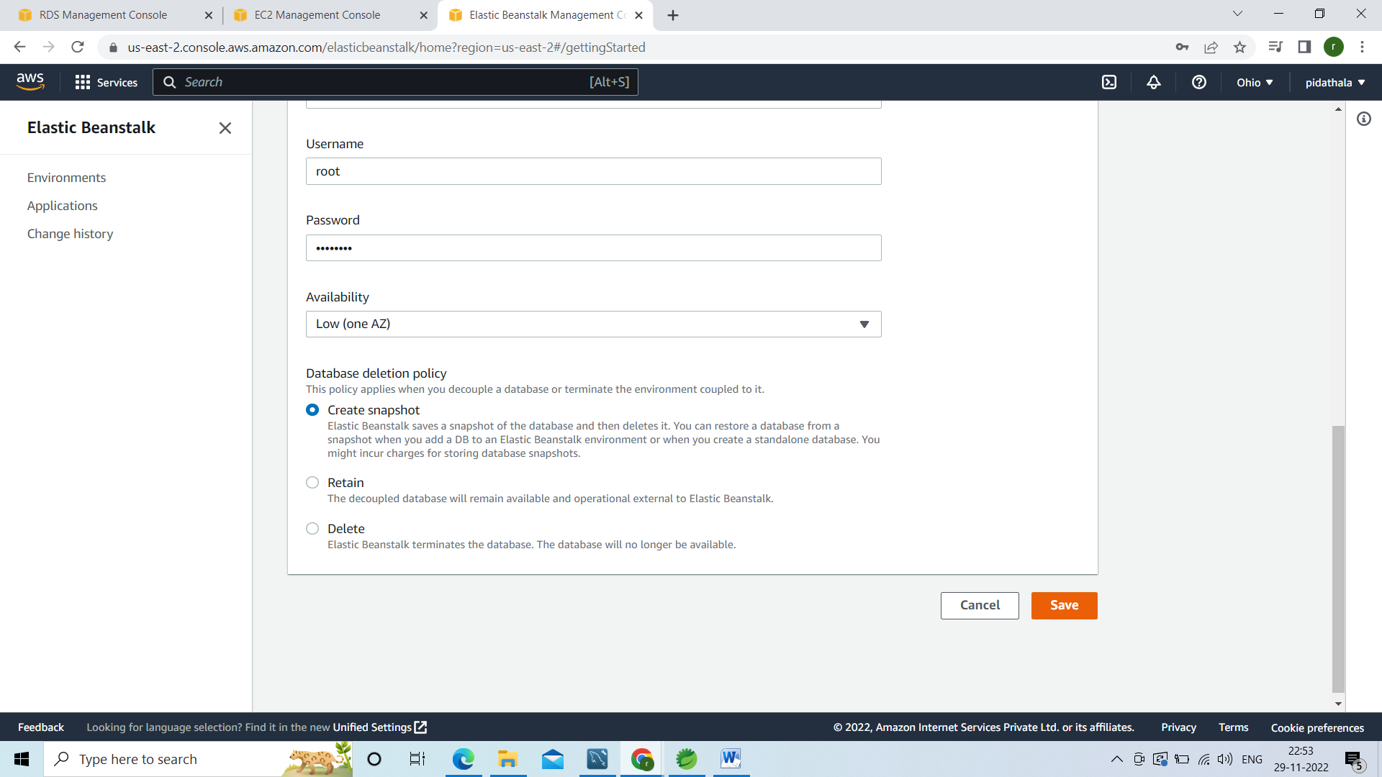

After save click on create app

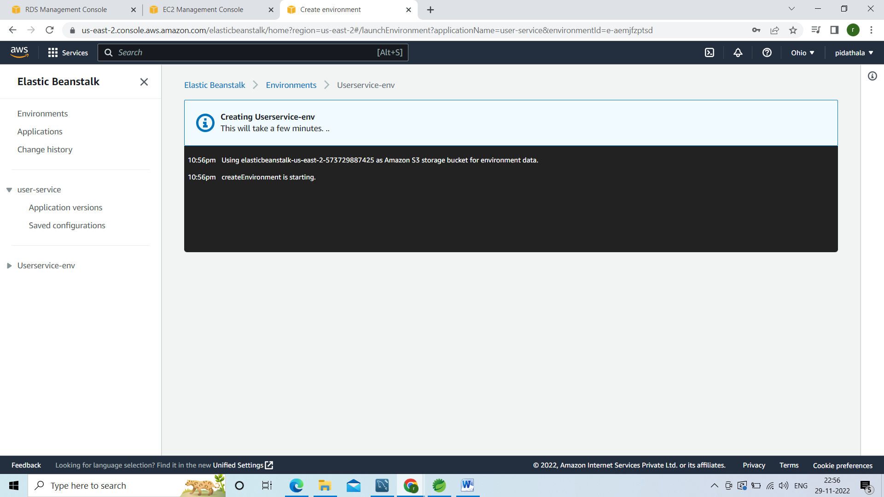

Environment has been created successfully

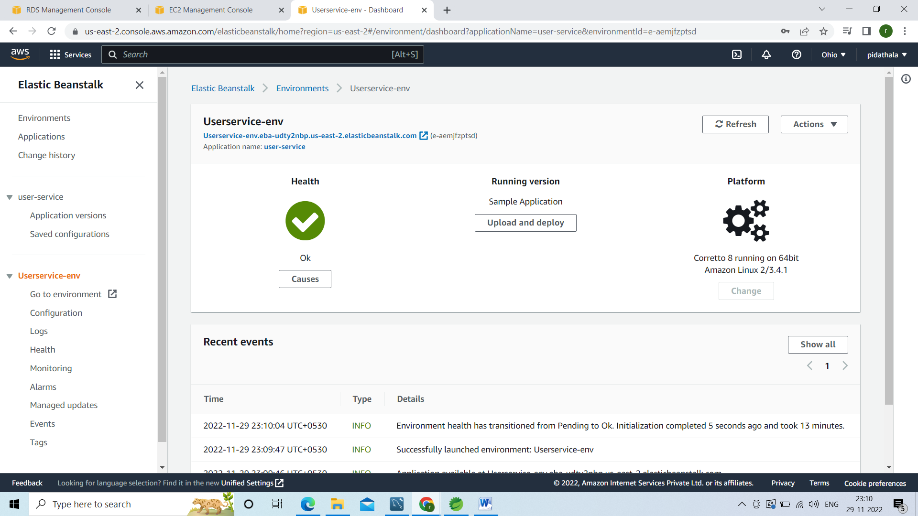

This is the URL

[**Userservice-env.eba-udty2nbp.us-east-2.elasticbeanstalk.com**](http://userservice-env.eba-udty2nbp.us-east-2.elasticbeanstalk.com/)

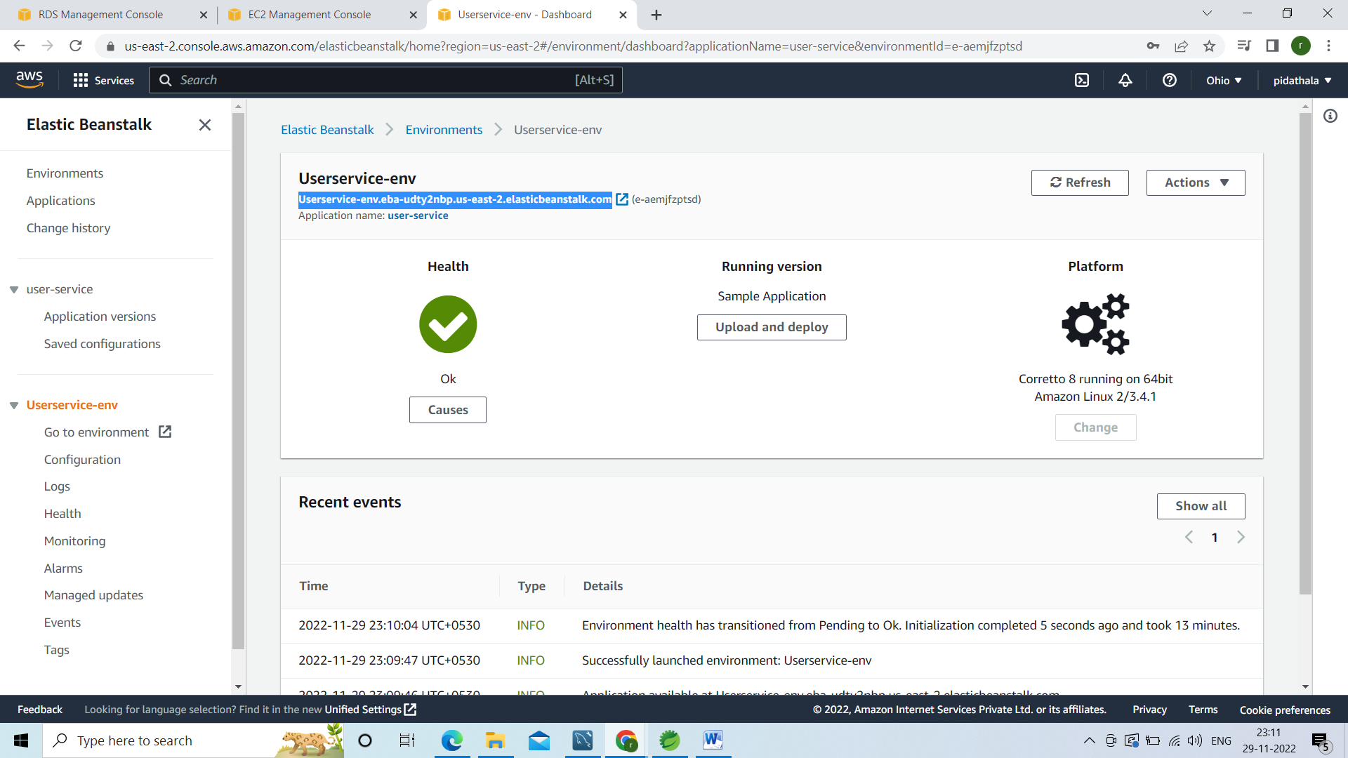

Now upload our artifact nothing but jar for that click on upload and deloy button

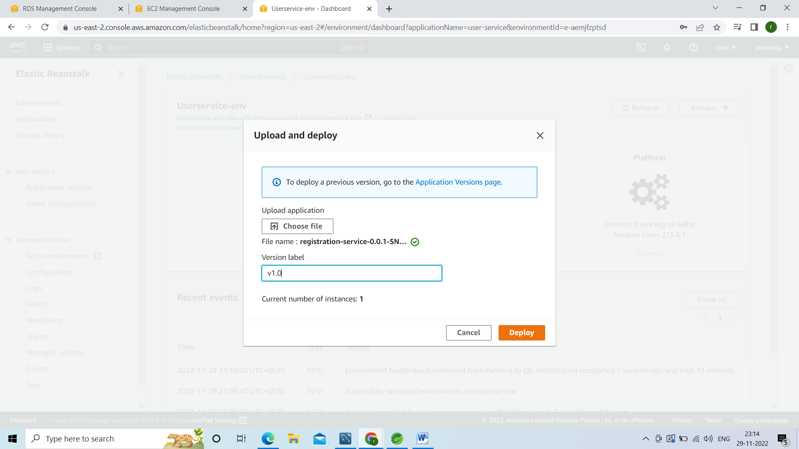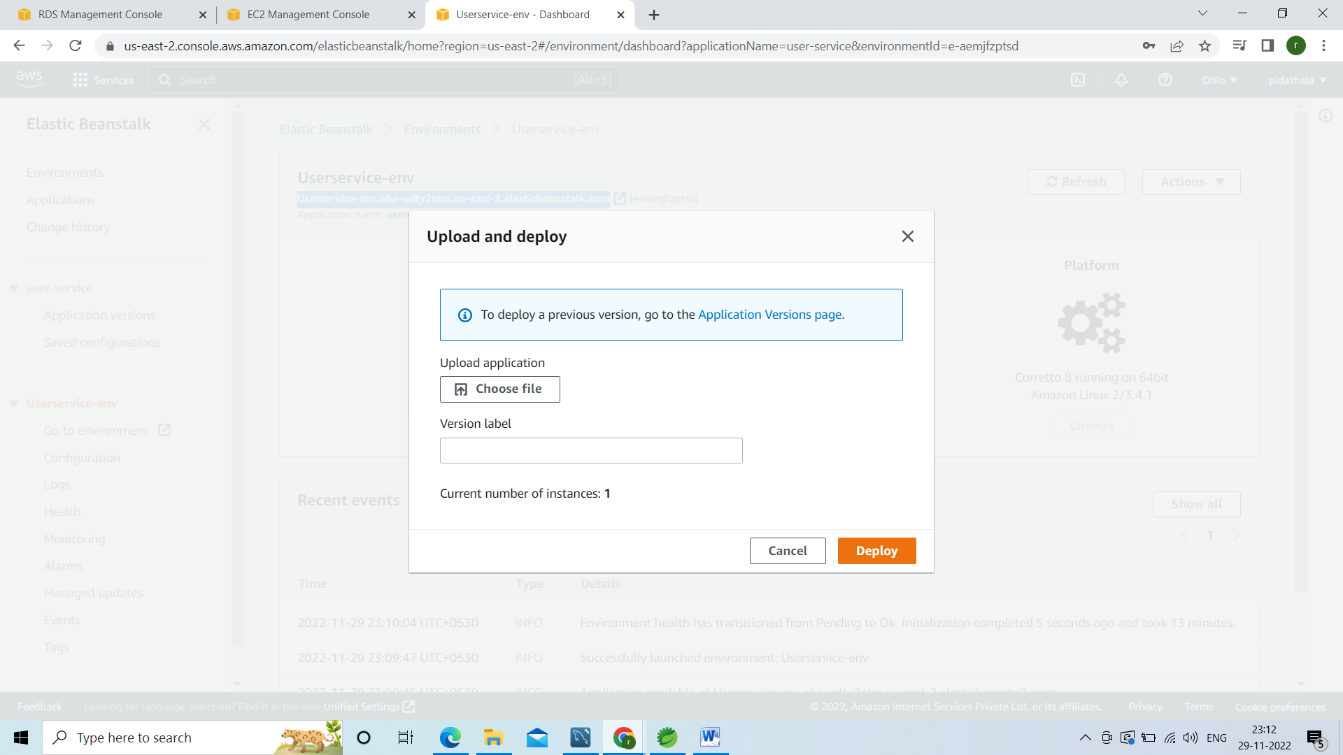

Click on choose file go to the location of ur project target folder and select the jar of ur project

Version label :sample

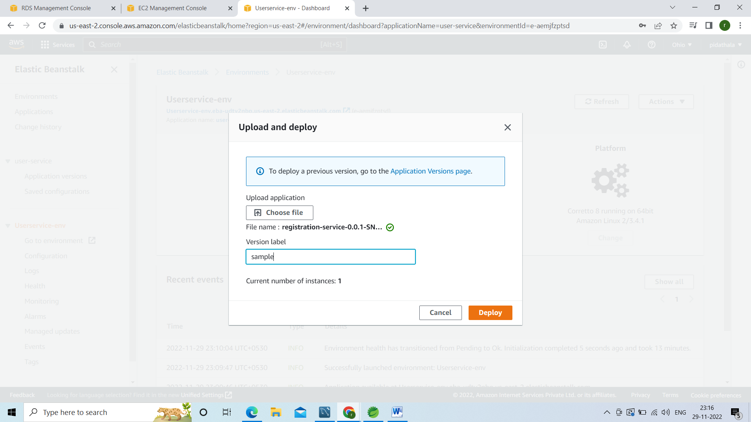

Click on deploy it will deploy the jar

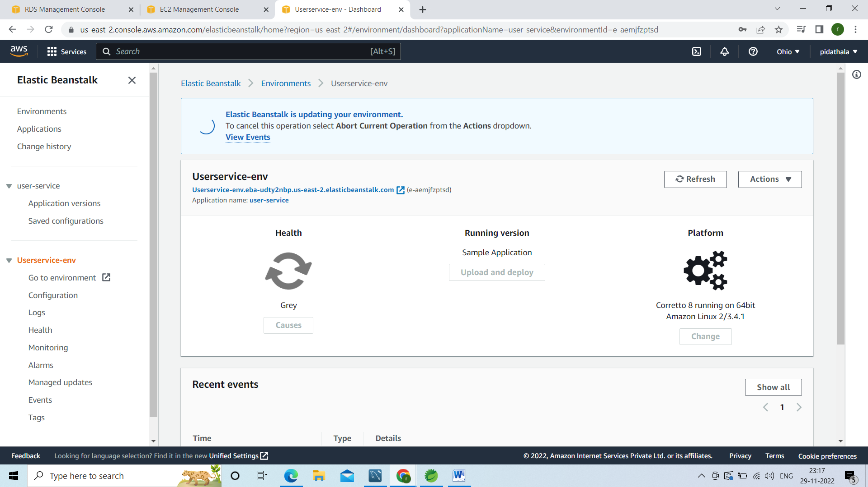

Deployed succesfully

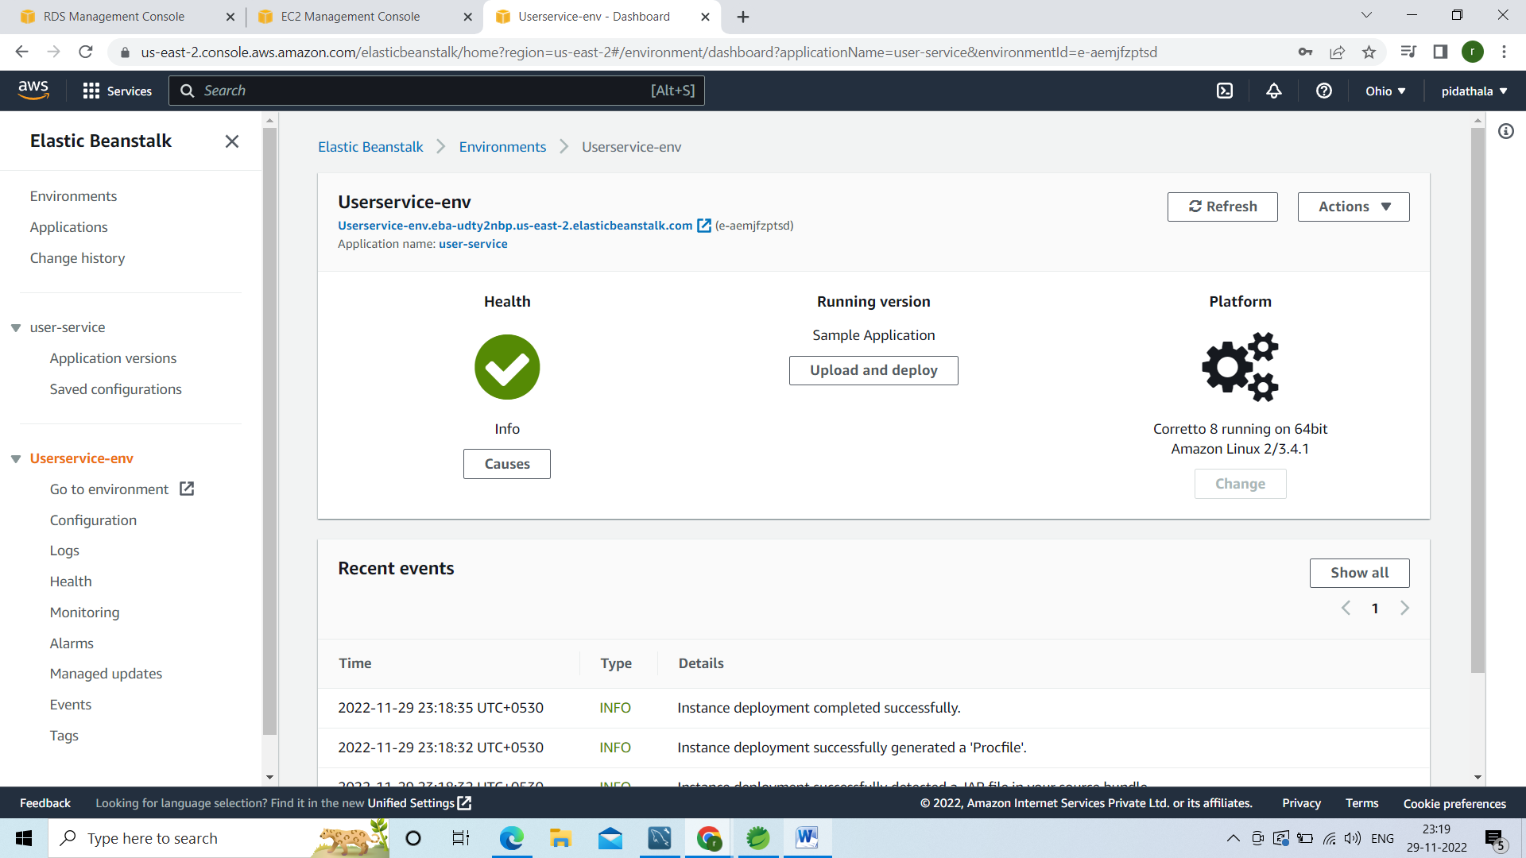

Copy this selected URL

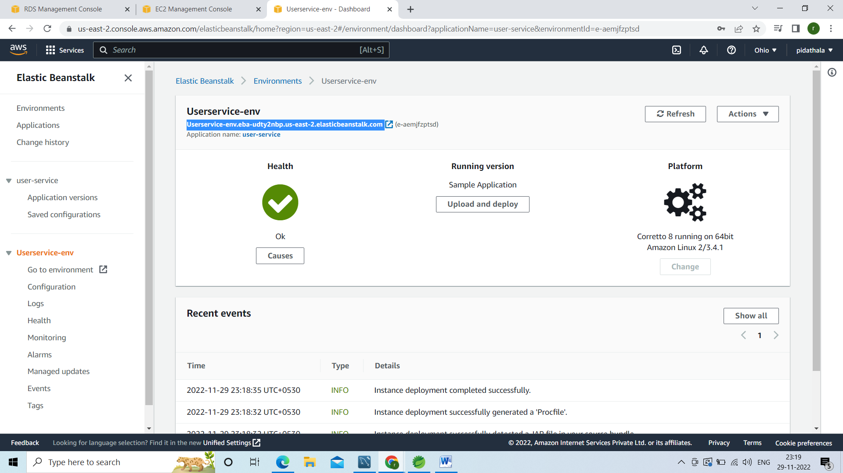

Copy this url and go to browser

U will get 404

Go to any end point from controller am taking getAllusers

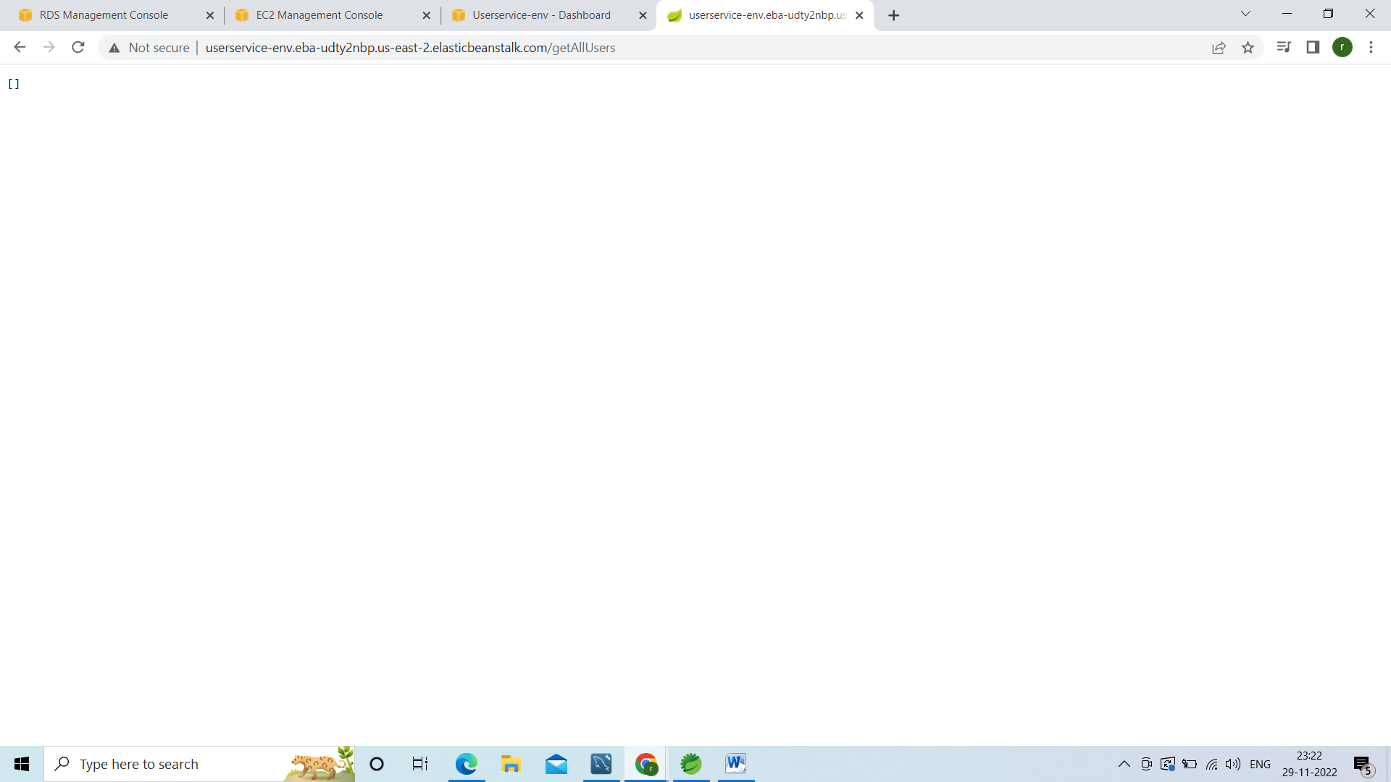

Got no data bcz we have connected to AWS RDS Instance DB there not added any data

Means our backend code is upon running

Now need to integrate with front end

Go to front end code there is a service class called user-registration-service

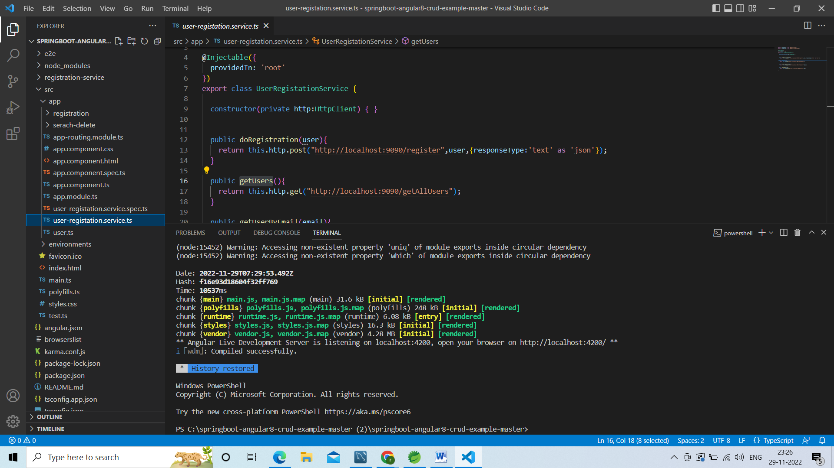

From this class we are doing rest api calls to our local application <http://localhost:9090> now we are not going to hit the local application just we need to consume the application which is configured in the AWS

Am adding ROOT_URl:String=””; go to the browser select the url

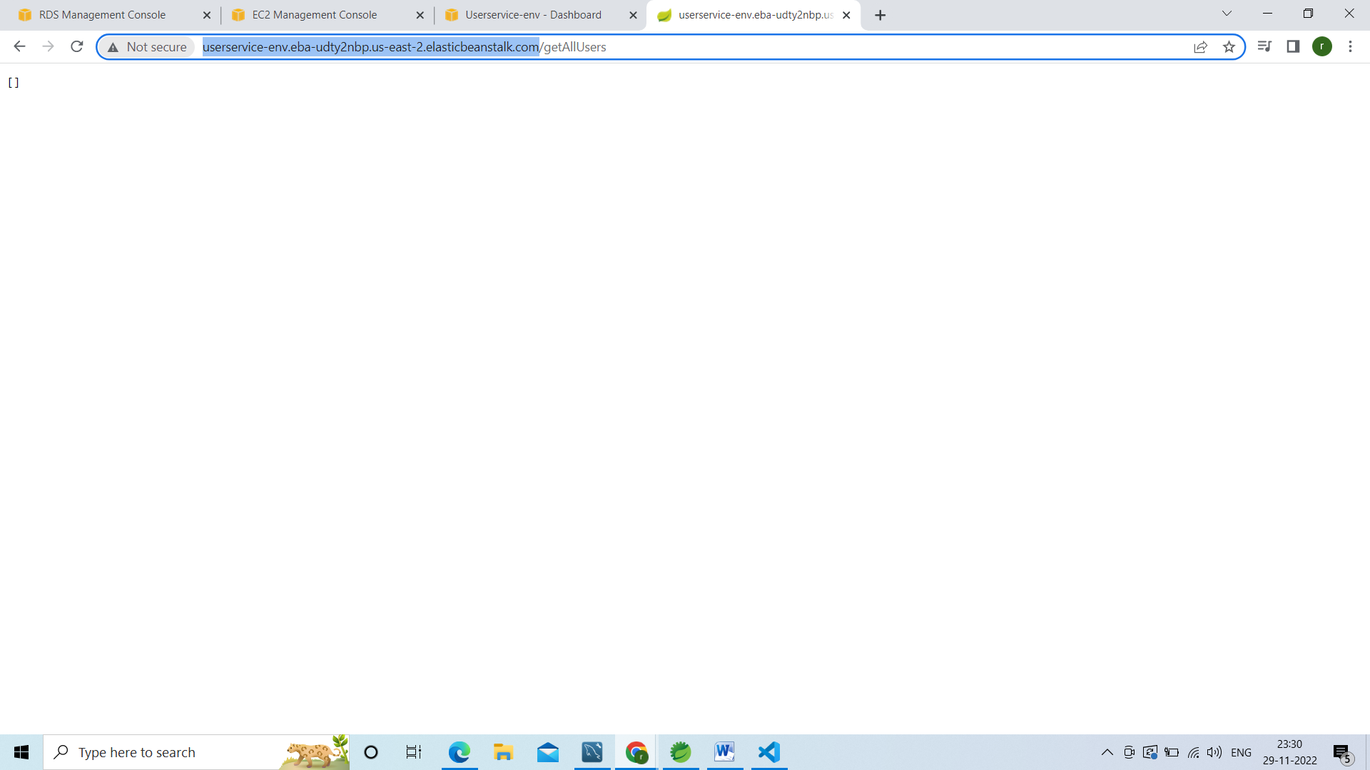

ROOT_URl:String=”<http://userservice-env.eba-udty2nbp.us-east-2.elasticbeanstalk.com>”;

Instead of

http://localhost:9090/

this add ROOT_URl

like below 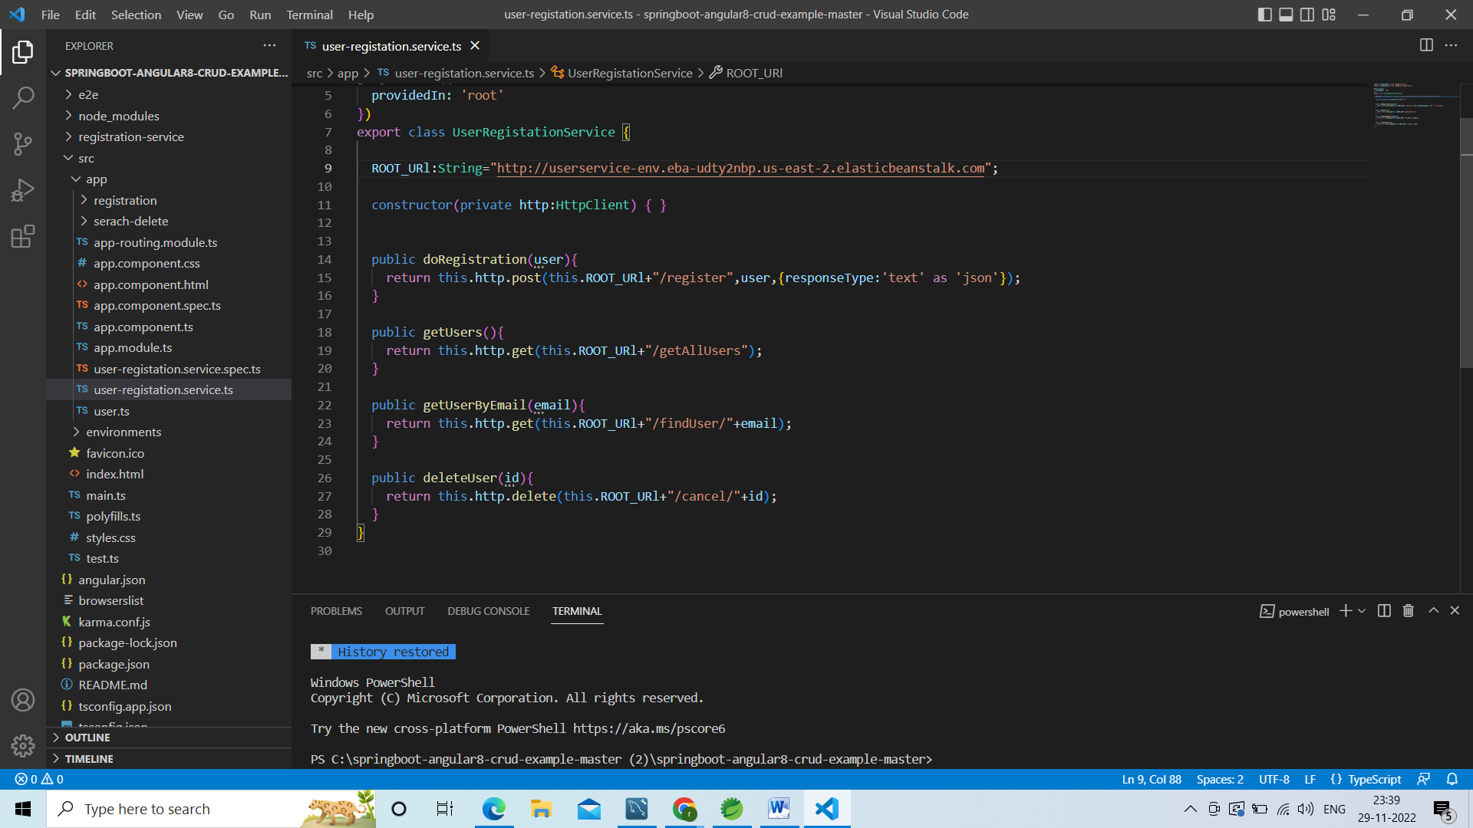

now alication will poin to the below url which is pointed to the AWS

<http://userservice-env.eba-udty2nbp.us-east-2.elasticbeanstalk.com>

now create the buid file in visual studio

ng build --prod

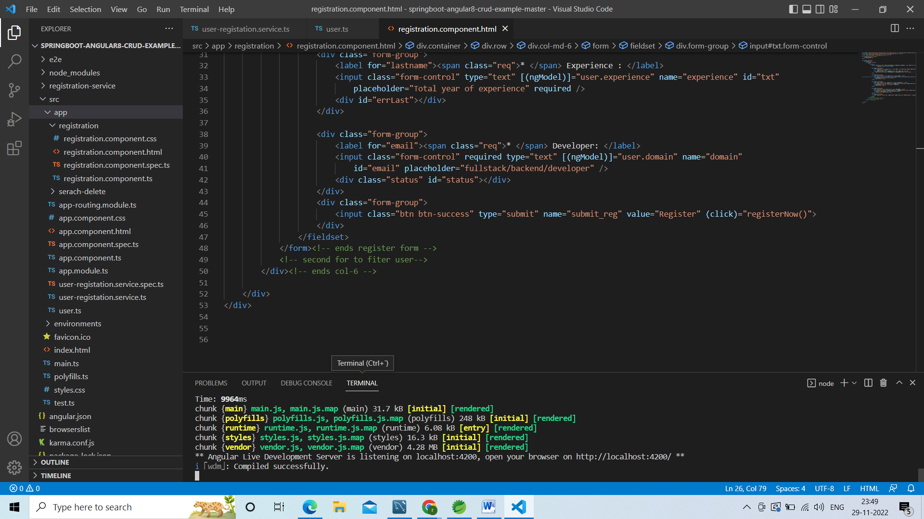

Go to the aws console and search for s3 bucket

Open it in new tab

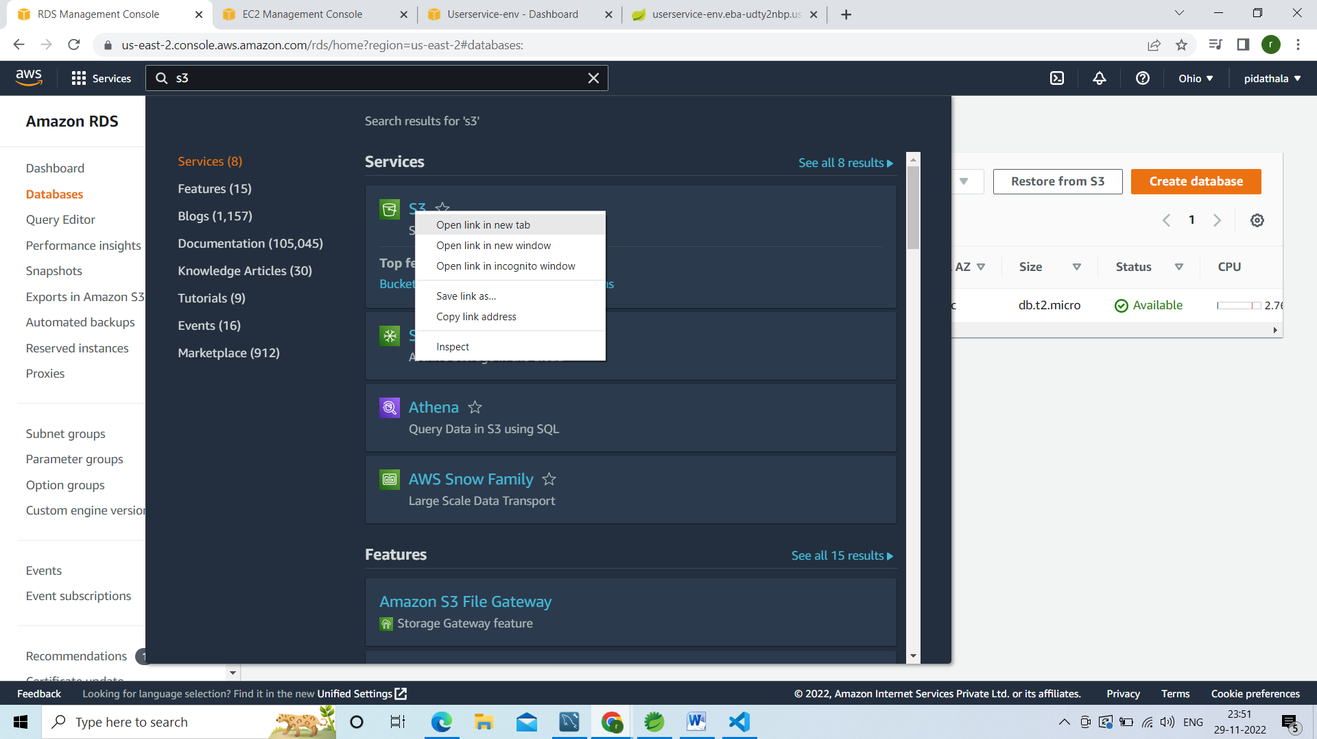

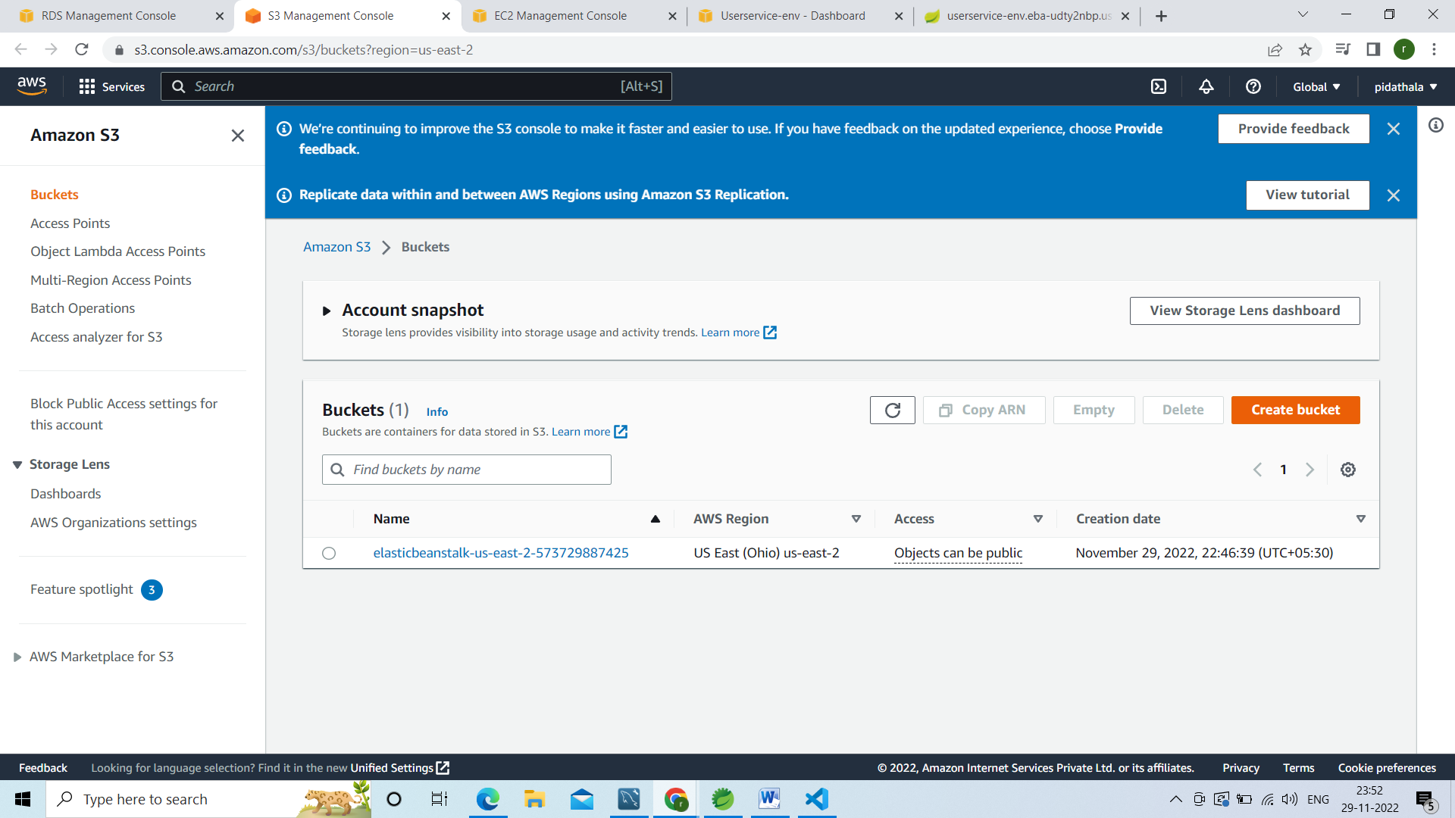

Click on create bucket

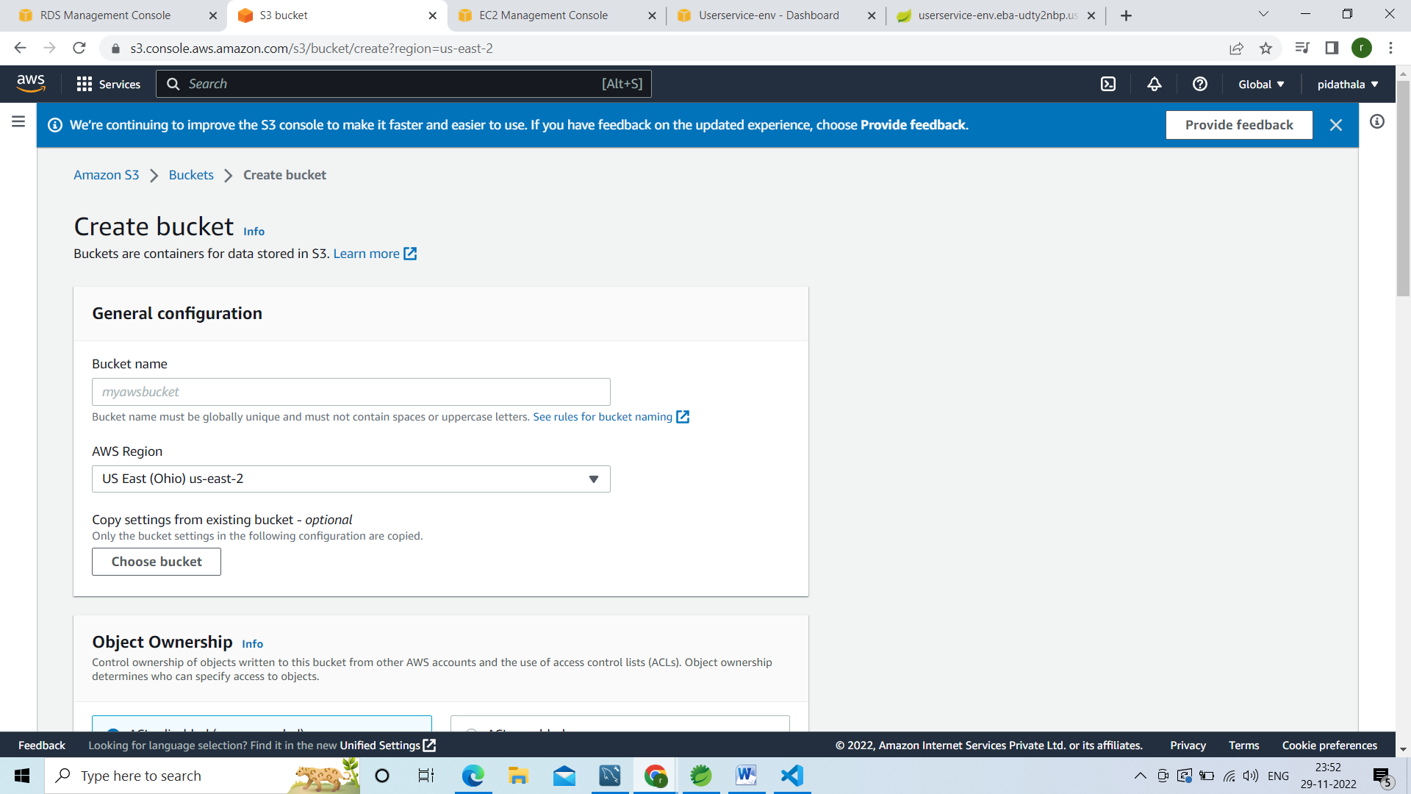

Bucket name ngcodeust

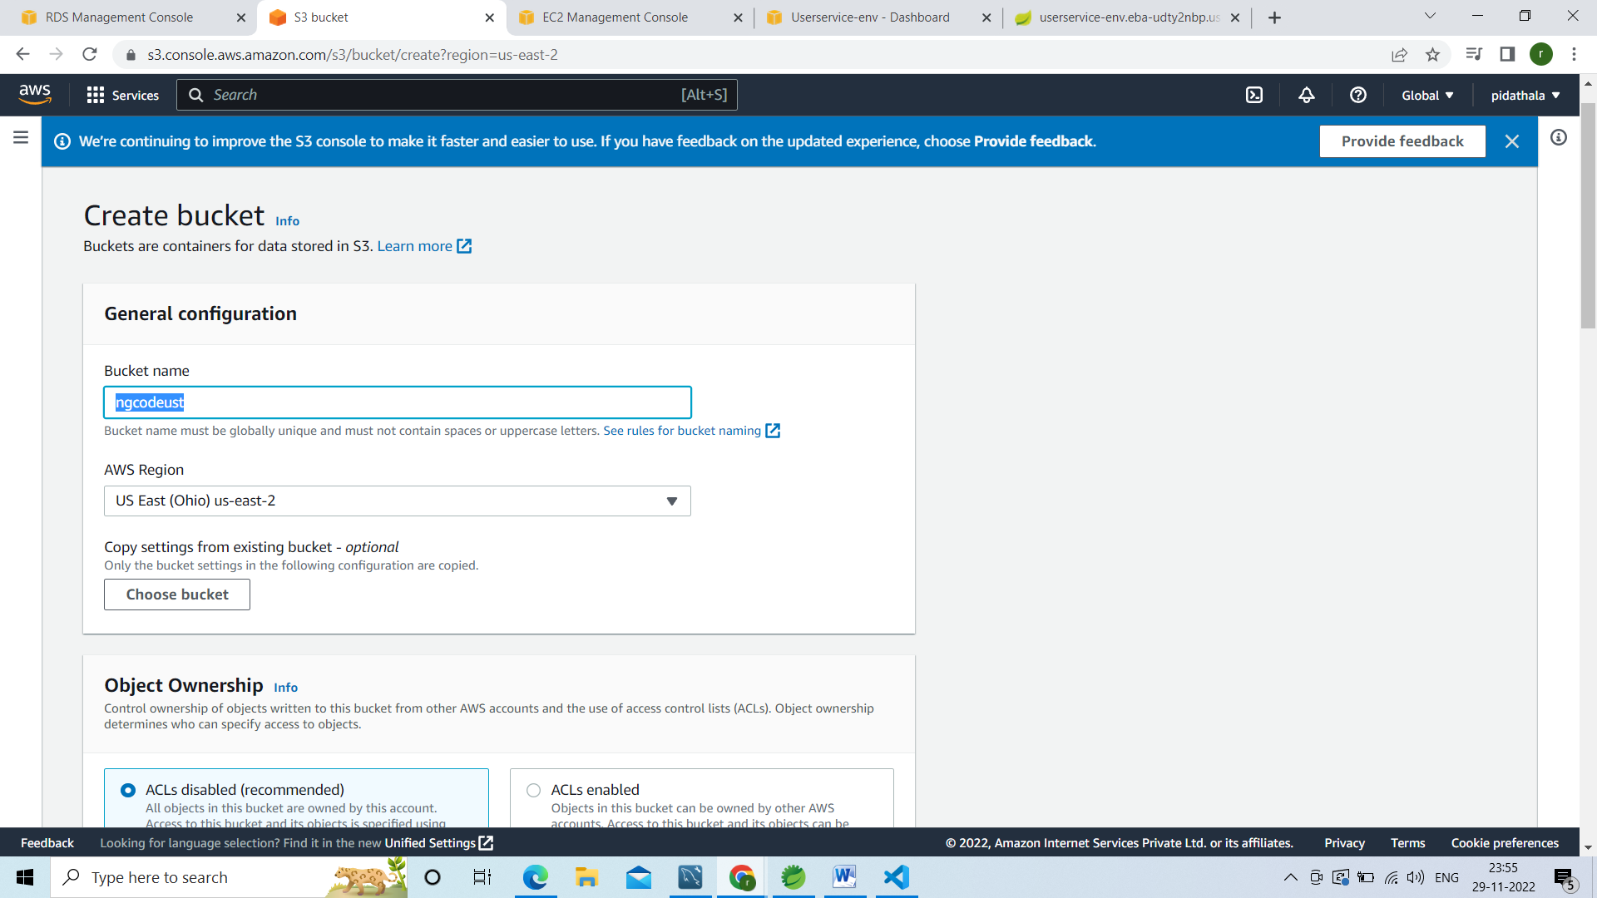

Unselect public access

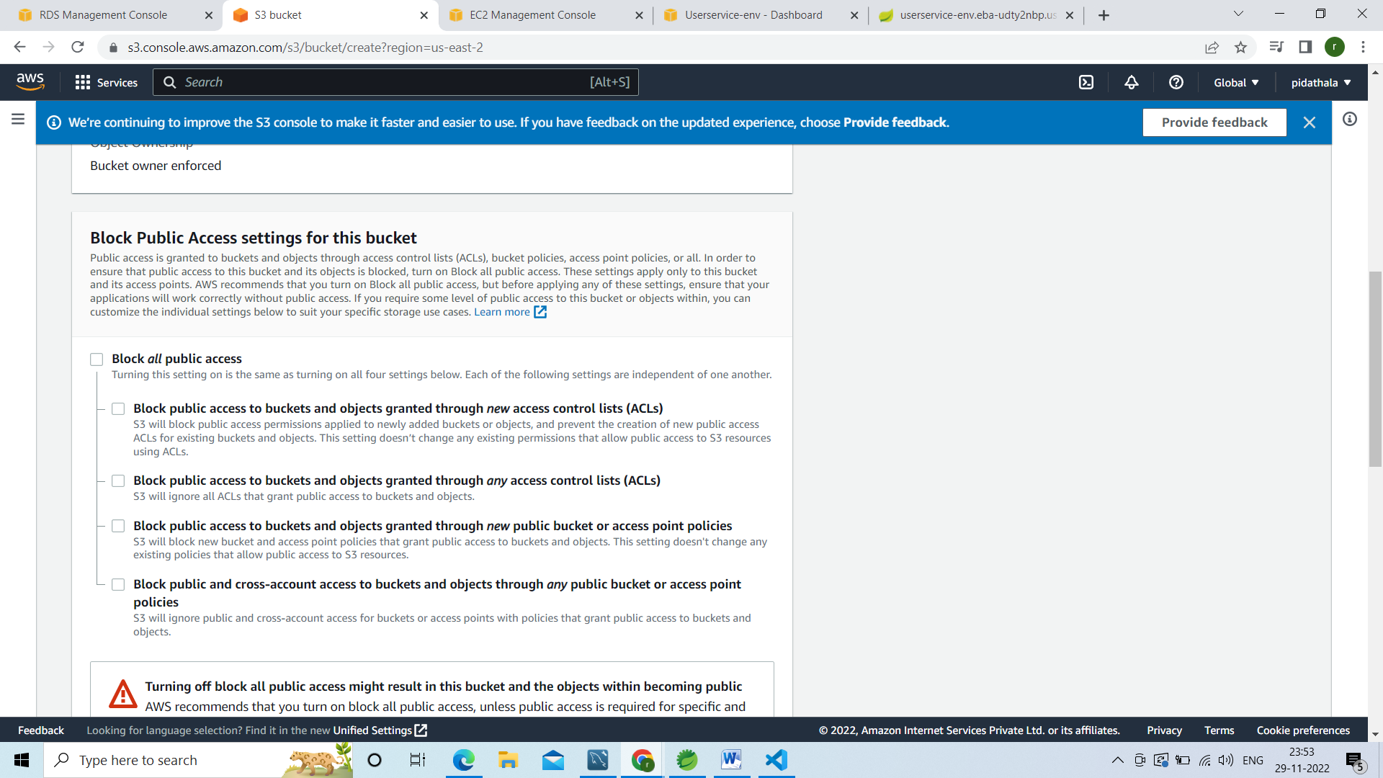

Aclknowledge check box

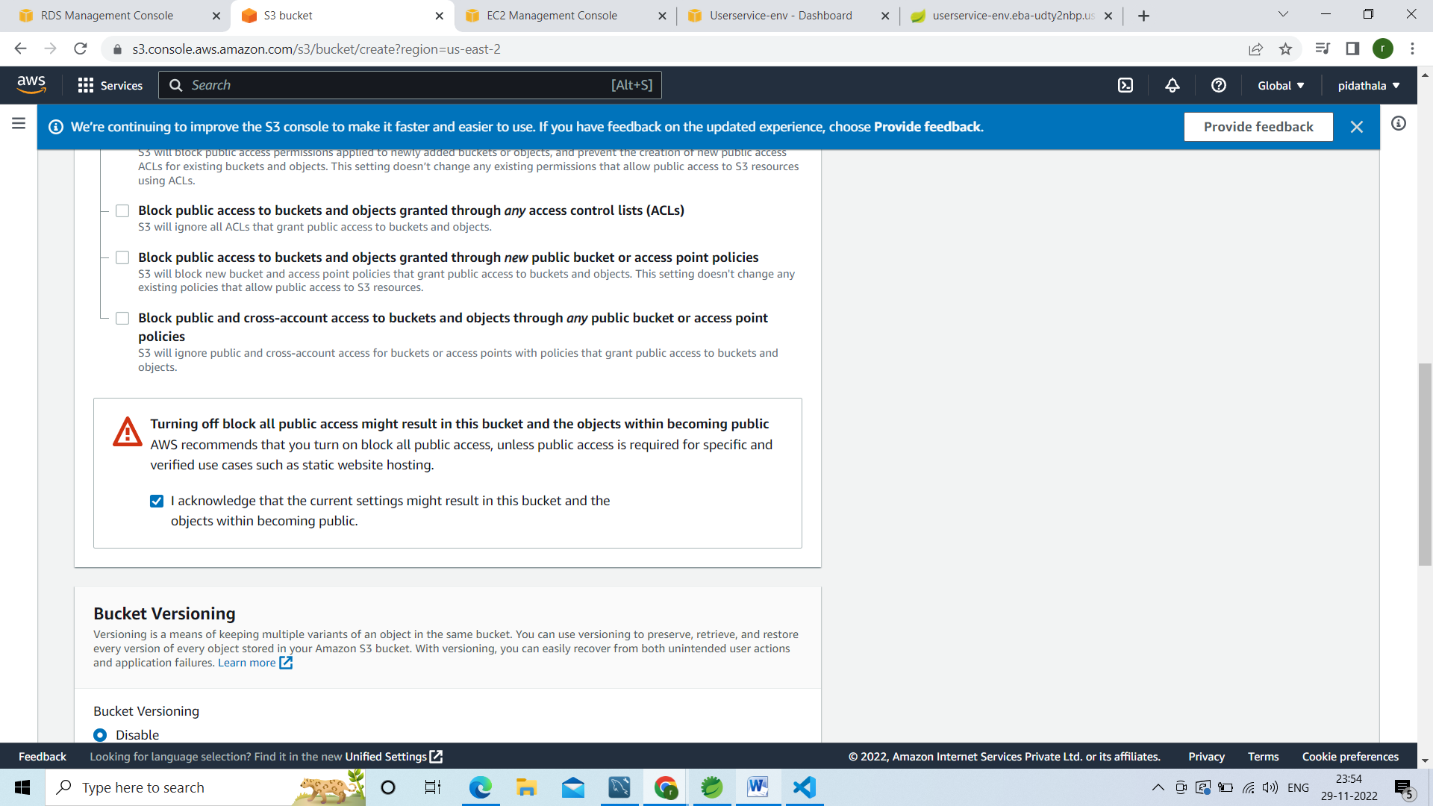

Cleick on create bucket

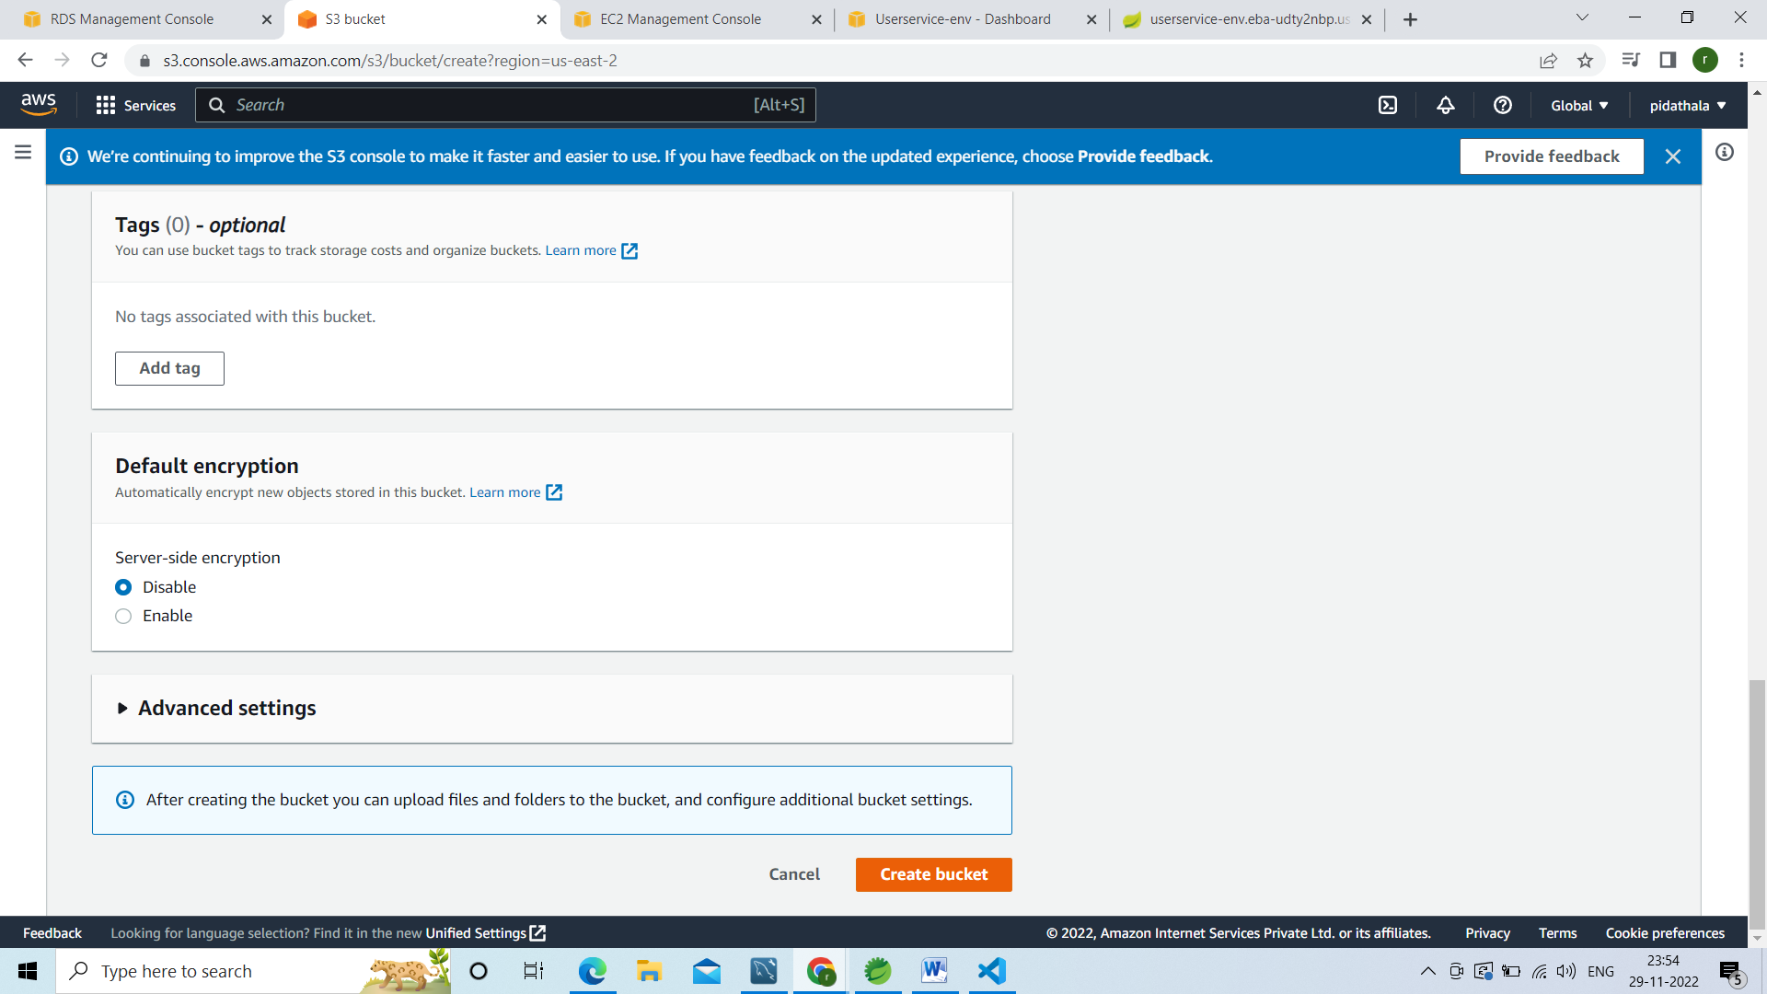

Succesfully created the bucket

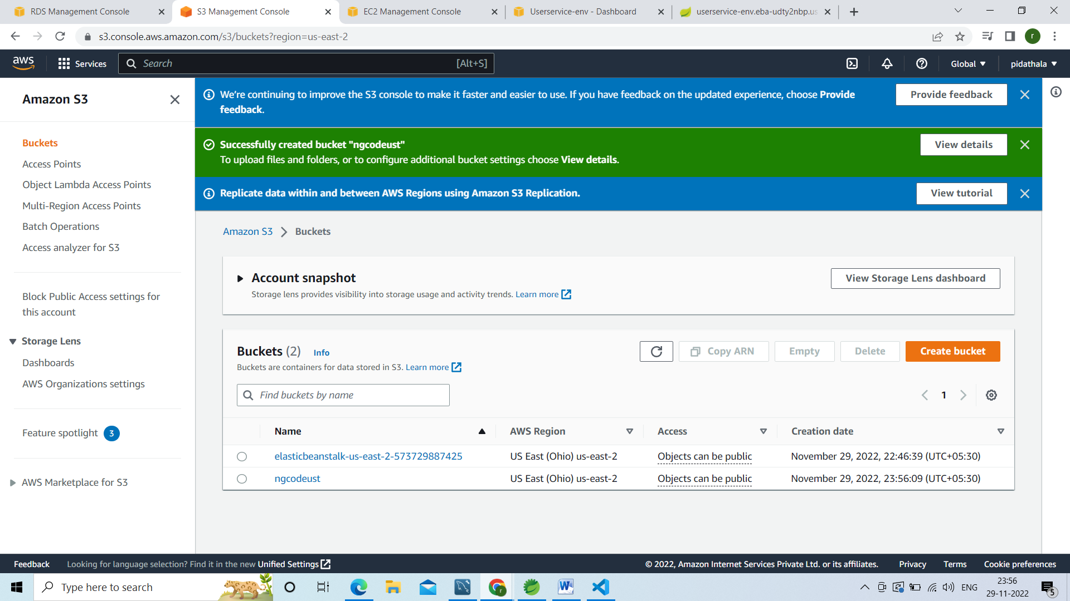

Click on ngcodeust bucket

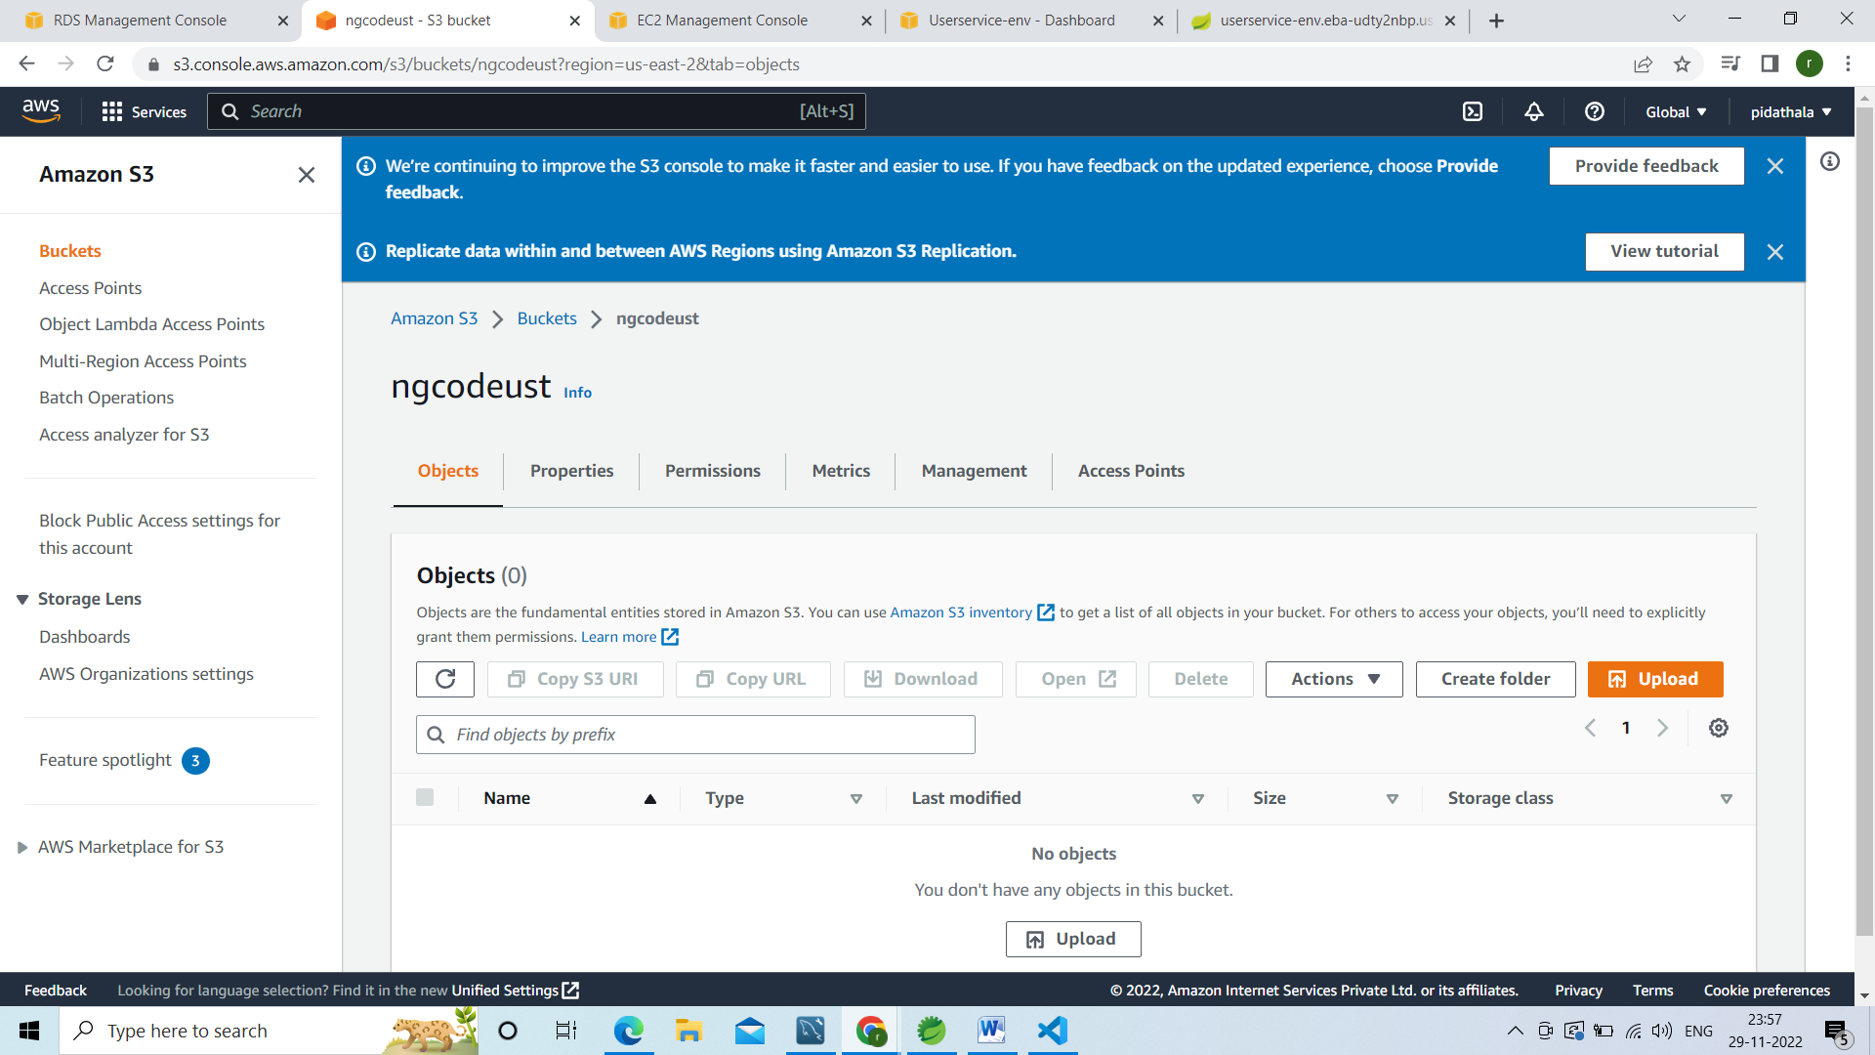

Upload client code

Click on upload

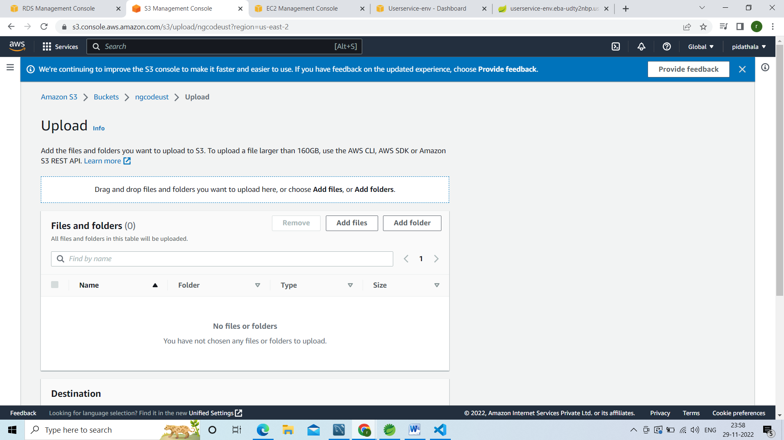

Go to the the angular code go to dist folder and select all the files

Click on upload

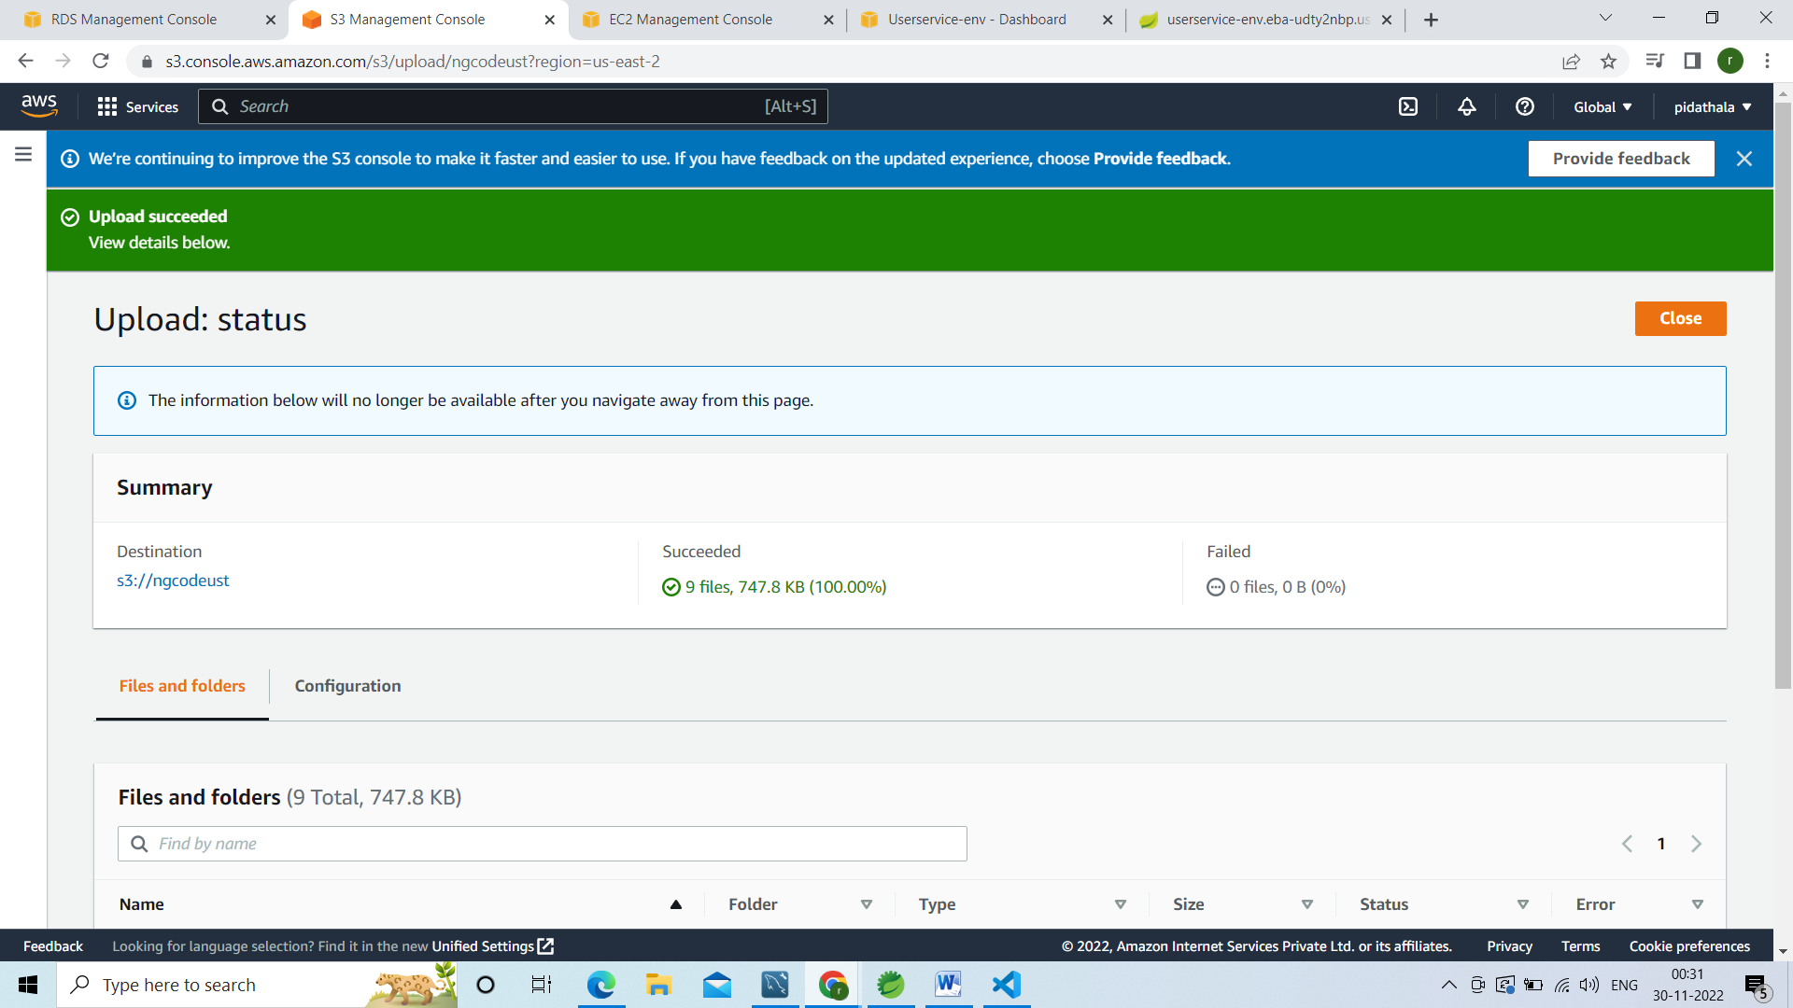

Then go to your bucket

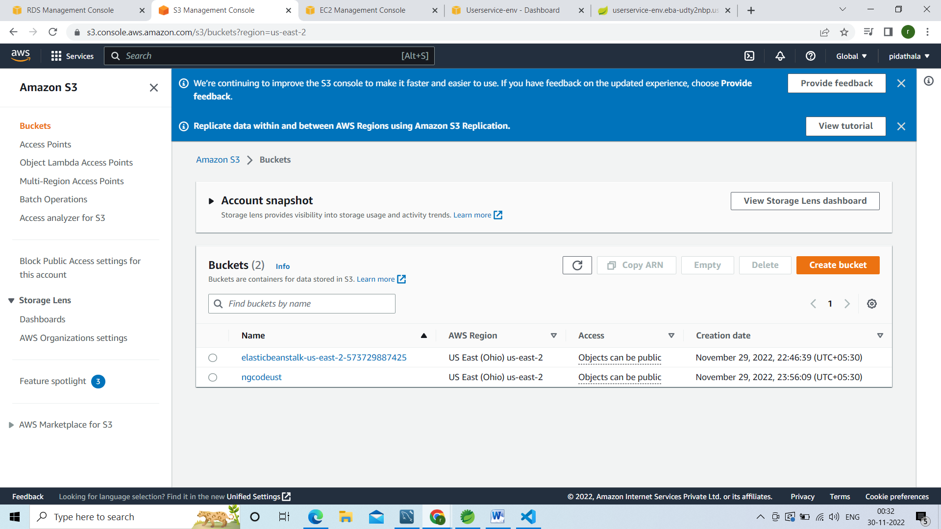

Click on that bucket go to properties

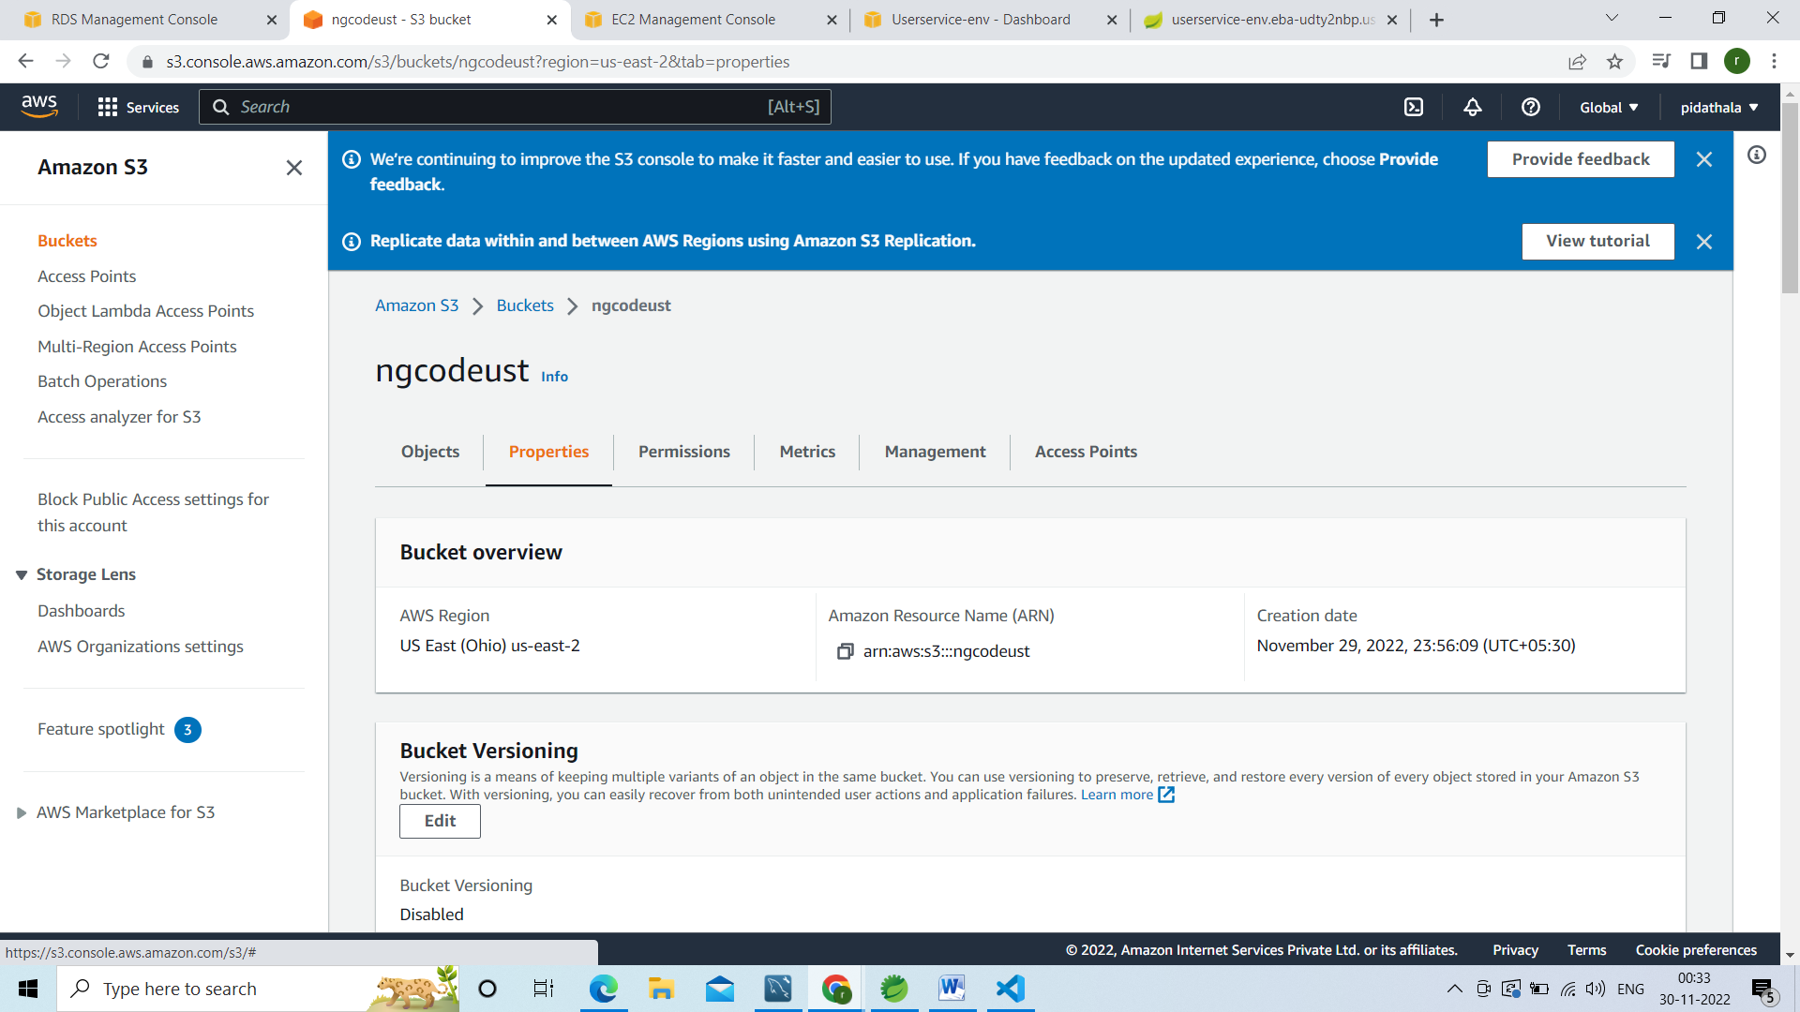

And host this application

## Go to Static website hosting

## Click on edit

## 

## 

## Click on enable

## 

## Give index document am giving index.html

## In error document also give index.html

## 

## Click on save changes

## 

## 

## Then go to Static website hosting

## U can see below url

## <http://ngcodeust.s3-website.us-east-2.amazonaws.com>

## 

## If u open that link in browser u will get

## 

## Go to permission tab

## 

## U have to add the s3 bucket policy

## Go to bucket policy and click on edit

## inside the policy

## Paste below lines

1. {
2. "Version": "2012-10-17",
3. "Statement": [
4. {
5. "Sid": "PublicReadGetObject",
6. "Effect": "Allow",
7. "Principal": "*",
8. "Action": [
9. "s3:GetObject"
10. ],
11. "Resource": [
12. "arn:aws:s3:::*Bucket-Name*/*"
13. ]
14. }
15. ]
16. }

## Bucket name means name of the bucket

## 

## Click on save changes

## 

## 

## Now go to the page refresh

## 